Common Cents – Fall 2015 to Spring 2016

# Energy Use and Wealth Creation

Its common ‘wisdom’ bandied about at water coolers, dinner tables, and political gatherings, that while the United States has 5 percent of the world’s population is uses 24 percent of the world’s energy. Sagely nods and enlightened shakes of the head always come in the wake of such an utterance. But what does this statistic really mean – that we are wasteful, that we take from others, what?

To the common man, this statistic indicates just how wasteful the United States is, just how predatory its consumption is, and so on. But it turns out that really isn’t the case. The real situation is much more nuanced and subtle and the results show a few ‘surprising’ things – surprising relative to the common wisdom and preconceived notions of just how bad the situation is in the United States.

First, the United States is comparable to its North American counterparts of Canada and Mexico in both energy consumption and wealth creation but actually ranks above both of them in how efficiently it use its energy. Second, the United States is much more efficient a wealth creation machine per unit energy than any other country its size in either Asia or Europe. Third, the United States produces a tremendous amount of energy, much of which is used by the rest of the world.

So the answer to the question posed above is that the fact that the United States has 5 percent of the world’s population and uses 24 percent of its energy doesn’t really mean much at all. Let’s see why.

## The Methodology

Good conclusions rest firmly on good data so let’s start by collecting individual statistics on the various countries around the world. The following table shows the population, gross domestic product (GDP) per capita, total GDP, energy use per capita, area, and efficiency (to be defined below) of 21 nations from various continents.

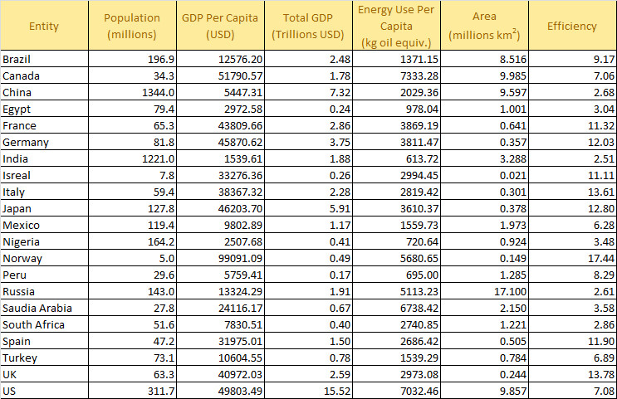

The data referenced to calendar year 2011 since that is the latest year where data were available for all 5 categories. GDP values have units of United States Dollars (USD). The unit of energy use per capita is [kilogram oil equivalent](https://en.wikipedia.org/wiki/Kilogram_oil_equivalent) (KOE), which is a normalized unit of energy that allows for world-wide comparisons.

To promote transparent discussions, each of the data points was obtained in the following way:

* Population and GDP values – Google search using ‘population <country name> 2011’
* Energy Use – Google search using ‘energy consumption <country name> 2011’
* Area – Google search using ‘area <country name> square kilometers’

where <country name> stands for one of the 21 names listed above.

The efficiency metric value is calculated as the ratio GDP per capita to energy use per capita and, as a result, has units of USD/KOE and state how much, in terms of goods and services, were produced per unit of energy.

## The Interpretation

Okay, with great data comes great responsibility. So how do we interpret the data responsibly? The first, and most obvious response, is to compare apples-to-apples. The easiest way to do this is to compare energy use per capita in a bar chart.

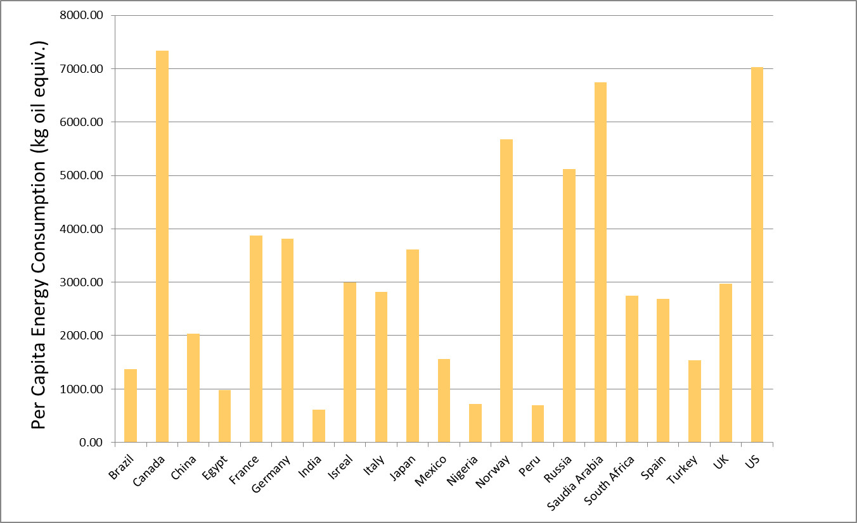

Perhaps surprisingly, Canada is the largest per capita consumer of energy in the sample studied. In 2011, Canada consumed approximately 7333 KOE versus the United States 7032 KOE. Saudi Arabia and Norway are close, consuming 6738 KOE and 5681 KOE, respectively. China, one of the world’s largest consumers of energy and one of the greatest polluters has a modest energy consumption of about 2000 KOE, two thirds less that the United Kingdom and about half of Japan.

But does this apples-to-apples comparison really tell us the full story? The answer is clearly no. What matters isn’t just how much of a commodity is consumed but also what is accomplished as a result of that consumption.

The situation has its analogy in basic family economics. It is one thing to spend (i.e., consume) $10,000 on a new roof and an entirely different matter to spend $1,000 on Pet Rocks. The first one is a larger expenditure, by a factor of 10 compared to the latter, but is clearly a better investment.

The most honest measure for what was produced by a country is the GDP per capita, taken as the value of all the goods and services made by the average citizen. There is no way to further evaluate the production beyond that since matters of cultural, societal, or philosophical valuation vary from person to person. The GPD measures, in some sense, what others in the market are willing to pay and nothing else. Nonetheless, it’s all there is.

This approach leads directly to the efficiency metric defined in the table above. When efficiency is displayed in a bar chart a much different story emerges.

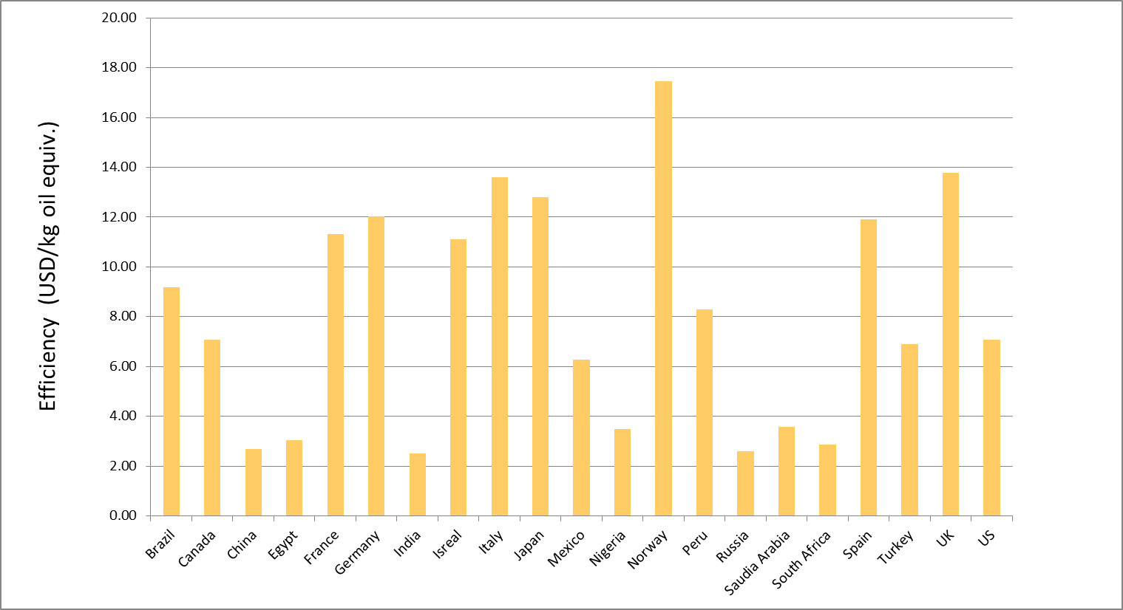

The United States and Canada each fall squarely in the middle of the pack, with their values of efficiency falling almost exactly on top of the median value for this sample.

At this point, the reader may be thinking that this is still not a true apples-to-apples comparison. After all, shouldn’t some adjustments be made for size and complexity of a country? The most obvious factors that I thought of that influence efficiency would be

* Climate (how hot or cold)
* Area (how big or small)
* Economic system (capitalist, social democracy, communist, etc.)
* Work force participation and training

Certainly a greater percentage of energy is consumed in colder countries compared to more temperate ones just to ensure the survival of the population, and this expenditure is not reflected in the GDP values. In addition, the amount of energy consumed for transportation is another expenditure that is not directly reflected in GDP. Finally, political forces shape the overall productivity of the work force either through the system of economic organization and/or through the percentage of able-bodied and trained citizens in the work force. The Soviet Union was notorious for having a very poor return on its energy expenditure even though it had immense resources.

Of these four factors, the only one that is relatively easy to work with is the size of the country in area, which is taken as a proxy for the size of the transportation expenditures. The following graph shows a scatter plot of efficiency versus country area.

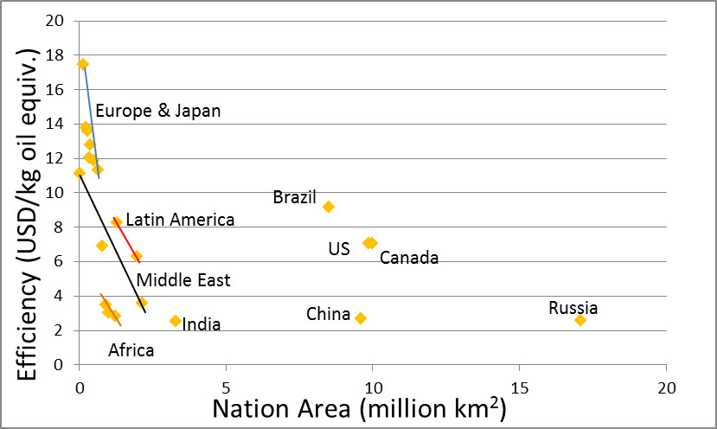

There are clear correlations between the size of the country and the efficiency, with the European (Norway, France, Germany, Spain, Italy, and the UK) countries and Japan topping the list. The Latin American countries (Peru and Mexico) also do pretty well although Mexico (with a 6.28 efficiency) definitely underperforms relative to its two neighbors to the north. For the most part the Middle East (Israel, Saudi Arabia, and Turkey) and Africa (Egypt, Nigeria, and South Africa) have terrible efficiencies well below the median, except for Israel, whose performance is indicative of the European countries.

For countries larger than 2 million square kilometers, only Brazil outperforms the United States and Canada. How much of this is due to climate is unknown but it is worth noting that Brazil has focused on energy efficiency and renewable energy sources in the past couple decades and some of that effort must be reflected in these numbers. Of course, it hasn’t been without a price as the cost of food in Brazil has risen over the years.

## Parting Thoughts

None of the analysis presented above is meant to defend the United States from the observation that energy is wasted. Most citizens in the United States pay only a little attention to how they consume energy since the cost to them is relatively small. It is clear that we can do better. However, it is also not the case that US citizens consume energy like a drunken sailor on leave spends money. Given the size of the nation, in both area and population, and the innovations and discoveries that originate here, the US makes a good return on the energy it consumes. In addition, the US produces the largest amount of oil and natural gas in the world, and is second in production of coal and the generation of electricity (<http://www.eia.gov/beta/international/>). It is patently unfair for intellectuals to continue to promulgate the myth that the US consumes energy at the world’s expense, a myth all the more dangerous since it is wrapped up in that innocent-looking little statistic that they like to throw around.

# Not all Inequality is Created Equal?

In a recent article in the Washington Post, blogger Ana Swanson reported on a new study in the field of economics that found some revealing and, perhaps, surprising results. The article, entitled, [*Why some billionaires are bad for growth, and others aren’t*](http://www.washingtonpost.com/news/wonkblog/wp/2015/08/20/why-some-billionaires-are-bad-for-growth-and-others-arent/), summarizes the findings of two economists, Sutirtha Bagchi of Villanova University and Jan Svejnar of Columbia University.

In their analysis, Bagchi and Svejnar, took [Forbes magazine annual list ranking the world’s billionaires](http://www.forbes.com/billionaires/list/#version:static), normalized the raw data to account for country size (either by GDP or by population or somehow – Swanson wasn’t particularly clear on this point), and then correlated the result with economic conditions in the country as a whole. According to Swanson, what the pair concluded was that as wealth inequality grew so did economic conditions for the general citizen worsen in the form of slower economic growth.

<They also found that their measure of wealth inequality corresponded with a negative effect on economic growth. In other words, the higher the proportion of billionaire wealth in a country, the slower that country’s growth. >

Also, the Bagchi and Svejnar correlated a percentage of the billionaires’ wealth to their political connections to the government. This measure of cronyism is supposed to help shed light on the positive and negative mechanisms that cause concentrations of capitol to exist in a country and that lead to wealth inequality. To illustrate this point, Swanson notes that the United Kingdom and Indonesia have similar [Gini coefficients](http://commoncents.blogwyrm.com/?p=83) (I found them to be 38.1 and 38.0, respectively, in the [World Bank Gini coefficient table](http://data.worldbank.org/indicator/SI.POV.GINI?page=1)) but that the business climate in these two countries are quite different.

The implication of this further analysis helps justify the title of the article – namely that not all concentrations of capitol come about for the same reasons and some billionaires are better than others.

In a nutshell, what Bagchi and Svejnar concluded were:

* [Gini coefficient](http://commoncents.blogwyrm.com/?p=83) doesn’t tell the whole story determining national growth
* Cronyism is a drag on the economy
* Innovation isn’t a drag on the economy

Wow! What a big surprise. I would never have seen that coming. Some billionaires actually deserve their fortunes because they enable rather than impede growth. To be fair, Bagchi and Svejnar didn’t actually state that billionaires who earned their money without political connections helped economic growth, simply that they didn’t impede it.

<“The negative effects of wealth inequality are largely being driven by politically connected wealth inequality. That seems to be the primary channel that drives this relationship,” Bagchi said in an interview.>

There are really two points that are worth addressing. The first one is on methodology. The second is on economic and philosophical outlook.

The methodology employed in the study requires one take the data with a grain of salt. For example, a few, simple queries of the Forbes list, Google, and the World Bank find the following data for Columbia and the United States.

|  |  |  |  |  |  |  |  |  |
| --- | --- | --- | --- | --- | --- | --- | --- | --- |
| Country | # of billionaires | Wealth Held ($B) | % Cronyism | GDP ($B) | Wealth held as % of GDP | Crony Wealth Held as % of GDP | Growth  Rate  (2013) | World Bank Gini Coefficient |
| [Columbia](http://www.forbes.com/billionaires/list/#version:static_country:Colombia) | 3 | 18.5 | 84 | 380.1 | 4.9 | 4.1 | 4.7 | 54.2 |
| [United States](http://www.forbes.com/billionaires/list/#version:static_country:United%20States) | 536 | 2564.4 | 1 | 18124 | 14.1 | 1.4 | 2.2 | 41.1 |

The data in this table do support the idea that the larger percentage of billionaires in the population the slower the growth as the percentage of billionaire-held wealth in the US is almost 3 times higher than that in Columbia. But that’s where the data stop making sense. Bagchi and Svejnar determined that 84% of the billionaire-held wealth in Colombia is due to political ties with the government. In other words, it is due to cronyism. In contrast, they found that only 1% of the billionaire-held wealth in the US is due to cronyism. Making the required adjustments, I found that ratio of Crony Wealth to GDP was 4.1% for Colombia versus 1.4% for the US and yet the Colombian GDP growth rate is double that of the US. Paradoxically, the Gini coefficient, which measures income inequality and is supposed to not be a reliable indicator of the harm that concentrations of capitol have on an economy, seems to be much more correlated with the Bagchi-Svejnar conclusion than their measure of ‘politically-connected wealth inequality’.

Perhaps the way that they chose to classify billionaire-held wealth is the problem. Well, I don’t have access to the original article so I can only quote what Swanson said

<So Bagchi and Svejnar carefully went through the lists of all the Forbes billionaires, and divided them into those who had acquired their wealth due to political connections, and those who had not. This is kind of a slippery slope — almost all billionaires have probably benefited from government connections at one time or another. But the researchers used a very conservative standard for classifying people as politically connected, only assigning billionaires to this group when it was clear that their wealth was a product of government connections. Just benefiting from a government that was pro-business, like those in Singapore and Hong Kong, wasn’t enough. Rather, the researchers were looking for a situation like Indonesia under Suharto, where political connections were usually needed to secure import licenses, or Russia in the mid-1990s, when some state employees made fortunes overnight as the state privatized assets.>

Now I’m not asserting that the Bagchi-Svejnar conclusions aren’t correct. They may be for all I know. I am asserting that there seem to be correlations that support some of their conclusions and others that don’t. Causation is another thing entirely.

Now on to the second point on the economic philosophy behind this whole revelatory study. Basically, these two economists claim to have discovered a data-driven conclusion that it matters how people get that wealth and how the government spends its money. In other words, that the basic neo-Keynesian idea about money and spending is wrong. That it is not enough for an economy to get money moving. [That is does matter if the work is productive](http://commoncents.blogwyrm.com/?p=182). That those who say “Go ahead and dig ditches even if you have to fill those ditches back up again. All that matters is that we’ve kept busy.” are wrong.

Of course, Bagchi and Svejnar may not say it quite that way but the conclusion is inescapable. For that matter, Ana Swanson may not say it that either but how else can one interpret the subtitle of her article ‘Not all inequality is created equal’!

# The China Syndrome

The year was 1979. Not a lot was known by the public about China, its people, its politics, or its economics. Nixon’s historic visit to the mainland had only happened about 7 years earlier and it was still a common occurrence to hear China referred to as Red China. On March 16th of that year, the movie entitled [*The China Syndrome*](http://www.imdb.com/title/tt0078966/?ref_=nv_sr_2) was released in theaters. The idea behind the movie was that negligence and corporate malfeasance at a nuclear plant led to a nuclear meltdown where the core metaphorically sinks through the earth all the way to China. Eerily, a scant 12 days later, [the accident at the Three Mile Island (TMI) plant](https://en.wikipedia.org/wiki/Three_Mile_Island_accident) in Dauphin County, Pennsylvania occurred. Suddenly, it seemed, all our worst fears about nuclear power were realized and the word ‘China’ had suddenly taken on a sinister meaning independent of the nation in the Far East.

Now with the benefit of hindsight, we can see that the TMI disaster, while serious, was not the catastrophic event that we feared. Even the far more serious nuclear accidents at Chernobyl and Fukushima-Daiichi have had little in the way of global impact. Simple analysis of the size of the stored energy in these plants relative to the size of the planet suffices to show that.

However, we are witnessing a meltdown of the Chinese economy and the impact of this event promises to have a global impact. Curiously, there weren’t any prescient tales speaking the precarious nature of the Dragon’s economy released to theaters. Not even a book that made it onto the best-seller list.

Just to set the stage, let’s consider for a moment where we were just a few short years ago and what the popular wisdom was. The common idea, spoken by pundit and plebian alike, was that the ‘Middle Kingdom’ was soon to be the dominant player on the world stage. The reign of the US dollar as the reserve currency has drawing to a close and soon the Yuan Renminbi would be what all the cool countries used.

I was deeply skeptical because I have a long memory and remembered the depressing and relentless drum beat of the 1970s and 80s heralding the United States’ economic doom at the hands of Japan.

<insert clip>

By the early 1990s, it was clear that strength of the Japanese economy had been exaggerated and the systemic weaknesses ignored. By the turn of the century, the world started talking about [Japan’s Lost Decade](https://en.wikipedia.org/wiki/Lost_Decade_(Japan)) and their economy has yet to recover from that slump, now roughly a quarter of a century later.

I can’t be certain why this cautionary tale was forgotten 10 years later, when economists were all agog with the ‘new economy’ engendered by the internet and the dot com bubble came and went. Nor why the message was lost again about 5 years later when almost everybody was considering flipping houses and the sub-prime bubble grew and burst.

All that is certain is that the message got lost once more – drowned in incessant chatter about the new powerhouse on the world stage. Never mind that China was following a ‘if you build it they will come’ strategy that piled up debt. Never mind that China played with it currency and subsidized oil purchases to keep gasoline costs low. Never mind that the Chinese government built entire cities in which no one lived. All that mattered to the intelligentsia was that the Dragon of the East had figured out what we in the West couldn’t – how to get around the law that says there is no such thing as a free-lunch.

Of course there were voices out there that said something was wrong, but they were in the minority and weren’t heeded then. Now you can’t hear anything else but words of woe on China.

So how bad is it and for long should we have known? It isn’t clear how to answer either of those two questions. By some measures China is much better off than other countries. Consider the following table that shows the ratio of Government Debt to GDP for select countries. Compared to the US and Japan, China’s central government hold significantly less debt (source: <http://www.tradingeconomics.com/>)

|  |  |  |  |  |  |  |  |  |  |  |
| --- | --- | --- | --- | --- | --- | --- | --- | --- | --- | --- |
|  | Government Debt to GDP Ratio | | | | | | | | | |
|  | **2006** | **2007** | **2008** | **2009** | **2010** | **2011** | **2012** | **2013** | **2014** | **2015** |
| **Country** |  |  |  |  |  |  |  |  |  |  |
| US | 63.3 | 63.9 | 64.8 | 76.0 | 87.1 | 95.2 | 99.4 | 100.8 | 101.2 | 103.0 |
| UK | 42.5 | 43.4 | 44.5 | 52.3 | 67.1 | 78.4 | 81.8 | 85.8 | 87.3 | 89.4 |
| Greece | 100 | 106.1 | 105.4 | 112.9 | 129.7 | 146.0 | 171.3 | 156.9 | 175.0 | 177.1 |
| Peru | 37.7 | 33.1 | 30.4 | 26.8 | 27.1 | 24.4 | 22.4 | 20.5 | 20.3 | 20.7 |
| Brazil | N/A | 56.4 | 58.0 | 57.4 | 60.9 | 53.4 | 54.2 | 58.8 | 56.8 | 58.9 |
| Germany | 68.0 | 67.6 | 64.9 | 66.8 | 74.5 | 80.3 | 77.9 | 79.3 | 77.1 | 74.7 |
| Japan | 175.3 | 172.1 | 167.0 | 174.1 | 194.1 | 200.0 | 211.7 | 218.8 | 224.2 | 230.0 |
| China | 33.8 | 31.5 | 34.8 | 31.7 | 35.8 | 36.6 | 36.5 | 37.3 | 39.4 | 41.1 |

But by other measures, China is in bad shape. According to Forbes Contributor Kenneth Rapoza, [its total debt to GDP ratio is approximately 280%. Is that bad, it’s hard to tell since the US’s total debt ratio is about 332%](http://www.forbes.com/sites/kenrapoza/2015/05/09/chinas-total-debt-load-now-over-280-of-gdp/). Further on, the same article has this to say about China’s growth in debt:

<…China led all emerging markets and was ahead of most developing markets in terms of an increase in total debt to GDP over a seven year period ending in the first half of 2014. Only Portugal, Greece, Singapore and Ireland saw their debt burden increase, but that is mainly due to massive corrections in economic output.>

Perhaps the most telling point is that China itself feels that it is in trouble. It took the unheard of step of adjusting its currency three times in a short period of time this summer. It also has been buying stock on its own exchange.

Will China fall? It is hardly likely. What is more likely is that its spend-now-and-pay-later expansion is coming to an end. China will still be an economic giant and that’s probably good, after all it has an incredible comparative advantage just due to population size. But it is very unlikely that it will ever dislodge the West from its pre-eminent position until it corrects its internal problems with liberty and human rights. Unfortunately, that isn’t a movie plot that can sell.

# Hernando de Soto

In doing the research for the previous post on [China and government held debt](http://commoncents.blogwyrm.com/?p=232) and the earlier one on [energy usage and wealth creation](http://commoncents.blogwyrm.com/?p=210), one country stood out – the country of Peru. It stood out not because it topped any particular list but because of the great strides that Peru has taken over the last quarter century to reform it government and economy. These reforms are reflected in the very low ratio of government held debt to GDP and in the relatively high efficiency with which it uses energy to create wealth.

During the 1980s, the situation in Peru was quite different. [Hyperinflation](http://www.businessinsider.com/worst-hyperinflation-episodes-in-history-2013-9#peru-july-1990-august-1990-7), which totaled in at an amazing 2,220,200% in the five year period from 1985 to 1990, was a crippling problem, social unrest lead to the rise of the Marxist [Shining Path (Sendero Luminoso)](https://en.wikipedia.org/wiki/Shining_Path), and the population had little to no faith in the government, dubbing even their president as [Alan ‘Crazy Horse’ Garcia](https://en.wikipedia.org/wiki/Alan_Garc%C3%ADa).

During the 1990s, Peru elected [Alberto Fujimori](https://en.wikipedia.org/wiki/Alberto_Fujimori) and his policies helped put the country on a stable trajectory and get its macroeconomic house in order. But how exactly did he accomplish this transformation? Well government is complicated and any success it enjoys has many creators but the Peruvian economist [Hernando de Soto](https://en.wikipedia.org/wiki/Hernando_de_Soto_Polar) played a big role.

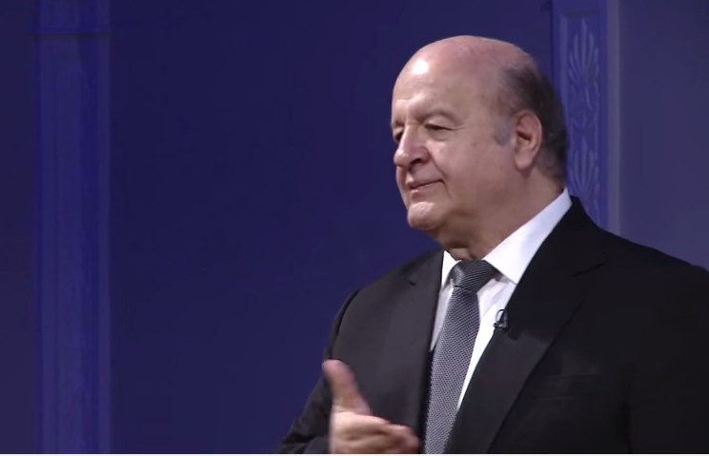

de Soto was born in the Peruvian city of Arequipa in 1941 but was moved to Switzerland in 1948 following a military coup and the self-exile of his father a diplomat. When de Soto returned to Peru he found that the economic situation was appalling. In reaction to this, he founded the Institute for Liberty and Democracy (ILD) whose influence helped to enact over four hundred laws and regulations enabling the poorer members of Peruvian society to benefit from the having access to capital.

de Soto is perhaps best known for his experiments with the ‘stopwatch’. The idea behind his experiment is to determine how long it takes for a prospective entrepreneur to open a business. In other words, de Soto hopes to quantify the transaction cost required to become a legitimate business owner who operates within the law and enjoys the corresponding privileges, including formal recording of the title of ownership and well-defined protection of assets under the rule of law.

What he found was depressing. He tried to setup a small shirt factor and discovered that it would take 278 full days to get all of the permits needed and that, along the way, the would-be business man had to navigate a level of corruption where the bribe was the accepted currency. NPR recently aired [an engaging piece on de Soto’s efforts](http://www.npr.org/2015/02/05/384119672/how-corruption-affects-the-time-it-takes-to-do-business) which premiered on their Planet Money regular feature.

<iframe src="http://www.npr.org/player/embed/384119672/384119673" width="100%" height="290" frameborder="0" scrolling="no"></iframe>

As a result of his efforts, Peru has gone from the hyperinflationary times of the 1980s to a sustained average growth of approximately 6.6% for the last decade while simultaneously having a very low percentage of government-held debt to GDP around 20%.

Due to these successes, de Soto has been called upon by many foreign governments to help craft economic policies suited to the developing world. As a self-styled [‘third-worlder’](http://www.huffingtonpost.com/hernando-de-soto/piketty-wrong-third-world_b_6751634.html), de Soto maintains a fierce objection to the theses of many of the ‘western economists’ who publically maintain that there is too much capitalism in the world. He has been [powerfully critical of the general notion suggested by Thomas Piketty](http://www.independent.co.uk/news/business/comment/why-thomas-piketty-is-wrong-about-capital-in-the-21st-century-10251801.html) that capital causes friction between societal groups and that society should move away from such notions. de Soto convincingly asserts that Piketty engaged in [rash guesswork](http://www.independent.co.uk/news/business/comment/why-thomas-piketty-is-wrong-about-capital-in-the-21st-century-10251801.html) when analyzing the situation in the developing world and that [Piketty’s book *Capital in the 21st Century* represents Eurocentrism at is most extreme](http://www.independent.co.uk/news/business/comment/why-thomas-piketty-is-wrong-about-capital-in-the-21st-century-10251801.html).

The basic idea underlying de Soto’s analysis, is that there are really two types of economies in the world: legal and extra-legal. The world’s elite enjoy the benefits of working within the legal system – benefits that include most especially the right to their property. The rest of the world, some 5 to 6 billion, sits outside these protections. This group finds itself in the precarious position where the only protections they enjoy are arbitrary ones conferred locally by some microeconomic or microlegal structure. Go 2 miles in any direction and the protections vanish. Step one toe out of line and the protections vanish.

This lack of access to true capital, defined by de Soto as the formal recognition of property rights and all the protections implied by such a recognition, is what holds the poor down. He traces the self-immolation of [Tarek al-Tayeb Mohamed Bouazizi](https://en.wikipedia.org/wiki/Mohamed_Bouazizi), which led to the Arab Spring, to the expropriation of his property – that is to say by the arbitrary way in which this street vendor was robbed of his wares and his livelihood because he had no formal protection for his property rights.

<iframe width="560" height="315" src="https://www.youtube.com/embed/6RXdLYP-dxM" frameborder="0" allowfullscreen></iframe>

While he cares most about the poor in the developing world and for ways to lift them out of the extra-legal economy and into the legal one, de Soto also has some criticism for the West. He has sharp criticism for the lack of transparency in both Europe and the United States evident in the recent financial crisis.

<iframe width="560" height="315" src="https://www.youtube.com/embed/r-n3ux36Rz8?t=21m45s" frameborder="0" allowfullscreen></iframe>

I suppose de Soto see these tangled webs of toxic assets, credit default swaps, and derivatives as steps in the wrong direction; as ways in which the elite erode the property rights of many to enrich a few. I think he’s absolutely correct.

# Comfortably Numb

The year was 1979 and the rock band Pink Floyd had just released their concept album *The Wall*. Strains of *Young Lust* and *Another Brick in the Wall* filled the halls in my high school. These are fine songs (who can argue with lyrics like “How can you have any pudding if you don’t eat your meat!”?) but the song that really spoke to me was *Comfortably Numb*.

It emotionally resonated with me because beneath its seemingly depressing façade was a defiant and cautionary tale of the price that’s ultimately paid by numbing the pain rather than rising up against it and fixing the root malady.

I’ve always kept that message, if not exactly that song, near and dear to my heart. Bodily pain is the nervous system’s way of telling you something is wrong and numbing the body, except in the case of corrective action like surgery, is a foolish thing to do. By masking those important signals, you are tricked into thinking things are fine until catastrophe hits and a serious problem has now become an insurmountable problem. Tell most anyone in our wellness-conscious society and you’ll get a quick agreement – at least where the body is concerned.

The situation is quite different when it comes to the economic pain and, for reasons I can’t explain, very few people seem to know or care about the numbness that is killing our economy. And what is this anesthesia that is causing the numbness – the policy of the Federal Reserve to keep interest rates, specifically the discount rate, at zero.

In order to understand how low interest rates is acting to numb the economy, I need to say a little about prices.

In an economy, prices serve three purposes:

* Terms of the exchange for completing a transaction
* Signal to the producer about the relative worth of a good or service as judged by the consumer
* Signal to the consumer about the relative worth of a good or service as judged by the producer

When you go to a store and wish to purchase a good the deciding factor is the price. Measured relative to your want or need, the price determines whether the transaction is made and you leave the store with the item or the transaction remains unfulfilled and the good remains on the shelf.

Looked at locally, within the confines of a single consumer, the price simply serves to help determine the relative worth of the good to the consumer. Taken globally, each successful transaction sends a message from the consumer to the producer that the relative worth of the good is favorable to the consumer. Each failed transaction sends the opposite message, telling the producer that the good is valued too high. The speed with which the good is purchased sends a message about whether the price is too low or too high.

Likewise, each price set by the producer sends a message to the consumer about how the producer judges the worth of the good against the producer’s outlay in its production. If the producer can’t entice a consumer to buy the product for more than it cost the producer to make it then the message is sent that the producer should stop making the product.

In effect, the price system functions as the nervous system in the economy, sending messages to and fro between different parts of the body politic saying to either make more or less of a particular good. Seen in this way, prices help regulate the economy so that the scarce resources available to society are best used – where best is judged by consumer demand.

When the Federal Reserve keeps interest rates low, it basically floods the economy with an anesthetic that interferes with the signals sent using the price system. Businesses that should have received the message that they are not producing products desirable to society are instead receiving a mixed or muted message that tells them to try again.

By keeping interest rates too low, the Fed allows businesses that should have failed to remain on life support with what is essentially free money. The idea that the Fed has is that it is compassionate to keep business going; that in order for the economy to grow, businesses need to succeed.

But why? What’s wrong with failure as a message? In the body, pain speaks volumes. It tells the body not to do whatever caused the pain. Learning from the pain is not the same as preventing it entirely, for without the pain no growth can occur. How can our economy grow if we can’t learn what works and, more importantly, what doesn’t?

Maybe the Federal Reserve should read less and listen to some Pink Floyd instead.

# A Flood of Hazards

Although the hurricane season for calendar year 2015 began on June 1 and ends on November 30, there really is no denying that the meat of the season falls in the middle to the latter end of that time span, particularly heating up (or is it raining down?) in late September if you are in the mid-Atlantic states.

They say all politics is local and so is best analyzed from that point-of-view. I don’t about how true that is but I do know that all weather is local and the local weather here in the mid-Atlantic region could be a lot better. As I am writing this post, Tropical Storm Joaquin is dumping lots of rain and the lights in my house have flickered a couple of times. Local television programming is festooned with crawlers that display a warning from the National Weather Service warning of the possibilities of flash floods.

Now, I don’t live in a flood zone but I am familiar with the struggles of those who do. I grew up in western Pennsylvania where floods were common and people I knew routinely lost personal property, entire houses, and even their lives, when the rivers crested above their banks. I am sympathetic to the poor and lower-middle class who were forced to near the rivers since that was where cheap housing was available. And every kid who went to school in my day was told cautionary tales about the great [Johnstown Flood](https://en.wikipedia.org/wiki/Johnstown_Flood) in 1889 that killed over 2,000 people in that small town in central Pennsylvania when a dam failed after days of heavy rain.

We were also taught about the importance that wonderful safety net that is federally funded flood insurance to help those who live in flood zones and, therefore, need the protection. For many years, I believed that claim without any skepticism, subjecting it to no critical analysis but later in life I was introduced to the idea of a moral hazard that changed my outlook.

The National Flood Insurance Program (NFIP) was established in 1968 with the express purpose of protecting people by providing what private insurance could not – flood damage protection. Homeowners and businesses in these areas could obtain flood insurance under the program and over its nearly 50 year history, NFIP has paid out over $43 billion in claims to over 5.5 million people ([source](http://blogs.colgate.edu/economics/files/2014/09/McGee-2014-Moral-Hazard-and-the-National-Flood-Insurance-Program.pdf)).

Under the program, homeowners or business located in federally designated flood plains are [required to buy the insurance](https://www.washingtonpost.com/opinions/hold-strong-on-flood-insurance/2014/02/02/5305ac62-8ab5-11e3-833c-33098f9e5267_story.html), although the full burden of the premium is not typical born by the insured. According to Mary McGee of Colgate University, in her article entitled [*Moral Hazard and The National Flood Insurance Program*](http://blogs.colgate.edu/economics/files/2014/09/McGee-2014-Moral-Hazard-and-the-National-Flood-Insurance-Program.pdf), homeowners and businesses pay only 10% of the actual actuarial cost of the premium. [Other sources](http://www.cbo.gov/sites/default/files/cbofiles/ftpdocs/82xx/doc8256/06-25-floodinsurance.pdf) put the percentage paid closer to the 35-40 % range, but everyone agrees that the insured doesn’t foot the entire bill.

On the surface, this seems okay since the target group to be insured was originally conceived to be the economically disadvantaged who afford housing on safer ground. But because homeowners and businesses don’t bear the full cost of this risk, they are encouraged to build in flood plains. In other words, rather than assisting lower-wealth people who couldn’t settle on higher ground the NFIP encourages people on the higher end of the wealth scale to take risks that they would ordinarily shun because someone else bears the cost. This behavior is a textbook example of a moral hazard.

According to a [CBO report on the NFIP (page 2](http://www.cbo.gov/sites/default/files/cbofiles/ftpdocs/82xx/doc8256/06-25-floodinsurance.pdf)), about 40 percent of subsidized properties are worth more than $500,000 and approximately 12 percent are worth more than a million. Rather than protecting the most vulnerable amongst us, federally-subsidized flood insurance is promoting risky behavior by those in society who can easily afford to avoid it. Both the [Washington Post](https://www.washingtonpost.com/opinions/hold-strong-on-flood-insurance/2014/02/02/5305ac62-8ab5-11e3-833c-33098f9e5267_story.html) and the [New York Times](http://www.nytimes.com/2008/03/18/business/18hazard.html?_r=3&) have called attention to this in articles about the unintended consequences of the NFIP.

Even the stalwart champion of responsible governance, John Stossel, has admitted to the fact that his very expensive home was replaced on our dime by the NFIP

<https://www.youtube.com/watch?v=_9MYyNYTcsM>

In the course of that debate, the fundamental fact that surfaced that the NFIP encouraged people to build expensive homes on coastal property because they knew that, should they suffer a loss, they would be restored. This is exactly the trend found by a group at NOAA. In the article [*Normalized Hurricane Damage in the United States: 1900-2015*](http://www.nhc.noaa.gov/pdf/NormalizedHurricane2008.pdf), the authors point out

Unless action is taken to address the growing concentration of people and properties in coastal areas where hurricanes strike, damage will increase, and by a great deal, as more and wealthier people increasingly inhabit these coastal locations. – R. A. Pielke Jr. *et al*

So until such time as the moral hazard caused by the NFIP, each natural flood of water will be accompanied by an unnatural flood of dollars leaving taxpayer’s hands ending up in the hands of people who built in a flood zone because they didn’t bear the cost of such risky behavior.

# An Interesting Warning

A recent article by Larry Summers, entitled [The global economy is in serious danger](https://www.washingtonpost.com/opinions/the-global-economy-is-in-serious-danger/2015/10/07/85e81666-6c5d-11e5-b31c-d80d62b53e28_story.html), recently caught my eye. For those who don’t know, Lawrence (Larry) Summers is a professor at Harvard and served as the Secretary of the Treasury from 1999 to 2001. No doubt the inflow of cash into the treasury during his tenure, a fact many economists credit to the ebullient spirit associated with ‘the new digital economy’ and the automatic stabilizers in the economy, did much to give him a reputation as an economic seer. But generally, I tend to take what he has to say with a huge shaker of salt mostly based on such idiotic sentiments as

<https://www.youtube.com/watch?v=CDCllPoroqg>

This current ‘chicken little’ prophesy of doom is really no exception. Although, to ‘be fair’, he does make some valid points in some areas but the bulk of his analysis is repackaged Keynesianism, which, oddly enough, may actually work in the particular situation the global economy is in.

In a nutshell, Summers warning center on secular stagnation where slow growth in the developed world hurts the emerging markets which, in turn, hurts the industrial countries.

<The problem of secular stagnation — the inability of the industrial world to grow at satisfactory rates even with very loose monetary policies — is growing worse in the wake of problems in most big emerging markets, starting with China. – Lawrence Summers>

To support this claim, Summers cites the IMF’s revision of growth forecasts for the US, Europe, and China downward. On the surface, this seems to be a slam dunk of a pronouncement but looking under the veneer one should ask if the IMF foresaw the global financial crisis of 2008. If they didn’t, which I suspect they did not, why start believing them now?

Summers also cites a curious statistic to make us feel all scared inside about the slowdown in growth in China. He points out that China poured more concrete in the time span from 2010 to 2013 that the United States did in the entire twentieth century. This statistic, [which is explained in more detail here](http://www.gatesnotes.com/Books/Making-the-Modern-World), seems genuine but who cares. Again, without any context whereby the statistic is put on level footing it is hard to know what to make of it. During the bulk of the twentieth century concrete was not the chosen material for building. Only in the last third of that century did steel reinforced concrete really rise to a common building material, with granite and brick being much preferred prior to that time. A more meaningful comparison would have been to show how much the US used in the span between 2010 and 2013 and even then the comparison would be misleading as the US isn’t trying to catch up to the developing world nor is it trying to lift over a billion souls up to a higher standard of living almost overnight.

In another curious meandering of his thought made manifest in print, Summers writes

<History tells us that markets are inefficient and often wrong in their judgments about economic fundamentals. It also teaches us that policymakers who ignore adverse market signals because they are inconsistent with their preconceptions risk serious error. – Lawrence Summers>

Okay, which one is it Larry? Should we ignore the market because it is inefficient and often wrong about economic fundamentals or should we listen to the adverse signals that originate from it?

Sigh…

Despite all this intellectual-sounding fluff, the odd thing is that I think Summers has a point. Currently the amount of money in the economy is high and inflation is low. More dollars should be chasing the same amount of goods leading to growth and, perhaps, inflation. But it isn’t happening.

Summers doesn’t seem to venture a guess as to why but he comes close to a hint. He mentions that China is suffering from a hangover due to unproductive investment. What a surprise – a Keynesian actually suggesting that economic activity is not enough – that an economy needs to invest wisely.

And so finally, we arrive at the only useful nugget to be found in Summers’ analysis. Governments, businesses, and households all have to be prudent and wise in their investments. In the late 90s through to 2008, they were generally overly enthusiastic and made stupid investments and took on unsupportable debt. Post financial crisis, governments have layered even more burdensome regulation on the economy; regulations that they continually tinker with to show how responsible they are. Businesses are sitting on cash timidly afraid to take risk. Households have hunkered down and are waiting to see what their so-called leaders will do.

Someone has got to get the ball rolling again and perhaps Summers is right in saying that it is government that needs to do this. But if this is the case, then businesses and household need to be vigilant in making sure that increased government spending is done wisely. We don’t need anymore hangovers.

# The Gravity of a Minimum Wage

Some economists have argued for a long time that the establishment of a minimum wage would have a negative impact on society as a whole but there haven’t been controlled experiments that I am aware of that try to support this claim. That is up until now.

As of April of 2015, we may finally have a Petri dish in which to examine the role of price fixing in the labor market and we have a man by the name of Dan Price to thank.

Dan Price is the CEO of Gravity Payments, a

CNN article - Gravity Payments CEO defends $70,000 minimum salary by Riley and Harlow - <http://money.cnn.com/2015/08/09/news/gravity-payments-dan-price-70k-salary/>

* Two employees left
* Some clients left
* Price read a study that concluded that gains personal happiness are large until about a salary of $75k
* 120 workers – 70 will rise – 30 will double
* Price cut his salary from 1 million to $70k
* Dozen’s of new clients
* Grant Moran, webdeveloper left, citing “Now the people who were just clocking in and out were making the same as me. It shackles high performers to less motivated team members."
* Price thinks any company can match his model –
  + springboard if everyone made a minimum of $70
  + how about earning it
  + where did happiness come from
    - Being ahead of their peers through fruits of their efforts
    - Being ahead of their peers in a financial sense

Business Insider article - A CEO raised his company's minimum wage to $70,000 a year, and some employees quit because of it by Rachel Sugar, <http://www.businessinsider.com/dan-price-gravity-payments-employees-leave-2015-7>

* Upon hearing the news, one employee said it would allow him to fly his mom from Puerto Rico to Seattle for a visit
  + How can he do this everyone makes $70k – airline tickets would have to be more expensive
* Two of the most valued employees have left
* Maisey McMaster, once a supporter, left after having doubts. “He gave raises to people who have the least skills and are the least equipped to do the job, and the ones who were taking on the most didn’t get much of a bump.”
* Possible silver lining: The employees who benefit from the bump are worrying that their performances don’t merit the money
  + Happiness may suffer as they now feel tied to the job by the money

Forbes article Why A $70,000 Minimum Salary Isn't Enough For Gravity Payments by David Burkus<http://www.forbes.com/sites/davidburkus/2015/08/02/why-a-70000-minimum-salaries-isnt-enough-for-gravity-payments/>

* Gravity is a Seattle-based credit card processor
* Inundated with emails, phone calls, and social media posts that have proved a distraction
* McMasters said she presented alternative ways to raise salaries but was told she was selfish
* J. Stacey Adam, organizational psychologist who laid the foundation for the equity theory of motivation is cited in the article
* <https://en.wikipedia.org/wiki/Equity_theory>
  + Everyone is always analyzing their outlay versus what they get in return
* Applies to pay raises just as much as pay
  + Of course it does – that this is a surprise to anyone shocks me

New York Times article: A Company Copes With Backlash Against the Raise That Roared Patricia Cohen, <http://www.nytimes.com/2015/08/02/business/a-company-copes-with-backlash-against-the-raise-that-roared.html>

* Some call him a thought leader
* Some a socialist
* Lots of people applied
* Clients left due to worries about passed-on fees or due to the discomfort of the political statement they perceived.
* Seattle entrepreneurs also didn’t like it
* Leah Brajcich, who oversees sales may have lured some back
* [Steve Duffield](http://www.dacocorp.com/blog/employee-spotlight-steve-duffield-vp-of-sales-co-owner-of-daco/), the chief executive of the DACO Corporation, who met Mr. Price through the [Entrepreneurs’ Organization](http://eoseattle.org/) in Seattle. “We can’t afford to do that. For most businesses, employees are the biggest expense and they need to manage those costs in order to survive.”
* Roger Reynolds, a co-owner of a wealth management company, said his discussion of the pay plan with Mr. Price got heated. “My wife and I got so frustrated with him at a cocktail party, we literally left,” said Mr. Reynolds, who complained that Mr. Price unfairly accused him of measuring his self-worth solely in terms of money and trying to hold somebody else down. Everyone may have equal rights, but not equal talent or motivation, Mr. Reynolds said. “I think he’s trying to bring in some political and aspirational beliefs into the compensation structure of the workplace.”
* Maisey McMaster was also one of the believers. Now 26, she joined the company five years ago and worked her way up to financial manager, putting in long hours that left little time for her husband and extended family. “There’s a special culture,” where people “work hard and play hard,” she said. “I love everyone there.” “He gave raises to people who have the least skills and are the least equipped to do the job, and the ones who were taking on the most didn’t get much of a bump,”
* Lucas, who lives in Seattle, declined to be interviewed but wrote in an email: “Dan has taken millions of dollars out of the company for himself while denying me the benefits of the ownership of my shares, and otherwise favoring his own interests as the majority shareholder over my interests.” He said his complaints predated the pay raises.
* Many employees listed are 30 and under
  + Too much money

<http://www.entrepreneur.com/article/249313>

# Yelping It Up

One of the most rich and interesting components of economics is associated with the management of Risk and Knowledge. As Taylor puts it in his textbook Principles of Economics: Economics and the Economy

“Every purchase is based on a belief about the satisfaction that will be provided by the good or service. In turn, these beliefs are based on the information that the buyer has available. But for many products, the information available to the buyer and the seller is imperfect or unclear, which can either make buyers regret past purchases or avoid making future ones. Timothy Taylor”

This interplay between knowledge and risk (I prefer the term knowledge over information as the former implies a judgment that the latter lacks) is profound. Management of risk in the face of what the future holds for securities is at the heart of hedge funds and derivatives.

Similarly, the issuance of insurance policies and the premiums by which they are underwritten is based on actuarial science where probabilities and impacts lead to expected outcomes and costs.

Interest required of a borrower is also linked to the risk that borrower represents in repayment and thus the interest rate is set accordingly – both in personal loans and in the offering or corporate bonds and stocks.

Naturally, we expect that a legitimate function of government is to ensure as free a flow of information as possible and we rightly view the pursuit of violators as a function of the courts. Just ask Martha Stewart about insider trading or Ford about the Pinto.

With the advent of the internet, it was natural to expect that there would be better flows of information now that most everyone was ‘wired’. Certainly CNet Reviews and Angie’s List seem to provide a forum for consumers to trade information on their experiences thus allowing others to gather knowledge and to make more informed decisions.

However, all is not well in paradise. An increasingly larger number of companies are making ‘gag orders’ a part of the implicit contract between seller and buyer, with often draconian punishment awaiting a buyer who has the temerity to place a bad review on Yelp or to speak unfavorably on Facebook.

These gag orders are the digital equivalent to insider trading. They are designed to keep information in the hands of a few and away from the buying public at large in the hope that, with less information, the public will make ill-informed and unknowledgeable choices.

And so it was with a some delight that I heard that Senator John Thune was providing [Yelp Help](http://wavy.com/2015/11/04/yelp-help-senate-moves-to-protect-users-honest-reviews/) by sponsoring [S.2044 - Consumer Review Freedom Act of 2015](https://www.congress.gov/bill/114th-congress/senate-bill/2044).



Under this act, consumers will be protected from the bullying gag clauses by declaring such clauses, usually hidden in the terms of service (talk about a lack of information), invalid, thereby ending the punishment that would accompany honest reviews. Gone would be stories of customers placing bad reviews on Yelp and then finding that they owe $3500 in fines for a dispute over $20 of merchandise. Businesses would still retain rights to sue for libel for any grossly inaccurate reviews. So kudos to what seems to be a sensible law that moves us one step closer to the ideal of a free flow of information.

# The Math Doesn’t Add Up

In his 1988 book [Innumeracy](http://www.amazon.com/Innumeracy-Mathematical-Illiteracy-Its-Consequences/dp/0809058405), the mathematician John Allen Paulos explores the inability of many people, some highly educated some not, to grasp what large numbers really mean. The book was something of a best-seller and is often discussed within certain intellectual and academic circles but its influence seems to be short-reached based on the fact that people still seem to be innumerate.

This failure is particular troublesome when the large numbers are associated with probability and statistics, and even more bothersome when the large numbers are about money and the statistics are about who hold what in terms of wealth.

A recent example of this kind of sloppy thinking is found in the following video, which went viral recently

<iframe width="560" height="315" src="https://www.youtube.com/embed/Zmji36q8E4o" frameborder="0" allowfullscreen></iframe>

As Neil Cavuto, the host of the show, pointed out to Keely Mullen, the organizer of the Million Student March, the central question here is not one of judgement but of numbers. Society can decide politically where it stands on her three core demands for free public college, the cancellation of student debt, and an across the board $15 dollar/hour minimum wage. The economics question is how to pay for it.

And here the innumeracy comes rushing to the front and crashing down on her. All she could say in defense of her program is that she doesn’t believe Cavuto that confiscating the wealth of the rich would not be enough to pay for her core demands. She couldn’t argue with his points.

At the heart of the discussion was the concept of ‘who pays for this all’. Here her poor understanding of large numbers has harmed her. The basic numbers are:

1. The [total wealth in the US held by households and nonprofits](http://www.pewresearch.org/fact-tank/2014/09/18/the-nations-wealth-recovers-but-largely-for-those-at-the-top/) is approximately $82 Trillion dollars
2. [The wealthiest 1% holds](http://www2.ucsc.edu/whorulesamerica/power/wealth.html), on average, 35.86% of the wealth
3. [Student debt is 1.2 trillion dollars](http://www.forbes.com/sites/specialfeatures/2013/08/07/how-the-college-debt-is-crippling-students-parents-and-the-economy/)
4. The [average US cost for public colleges](http://trends.collegeboard.org/college-pricing/figures-tables/2015-16-state-tuition-and-fees-public-four-year-institutions-state-and-five-year-percentage) is $9410/year
5. The [number of students enrolled in higher education](http://nces.ed.gov/programs/coe/indicator_cha.asp) is 17.5 million students

Now let’s do some trivial analysis. First let’s calculate the wealth held by the one percent by multiplying the percentage wealth held by the total wealth. This value comes out to be 29 trillion dollars of wealth. It is a misleading number but we’ll come back to that. Next let’s estimate the total cost for public college. A reasonable estimate is that about 2/3 of the student population attends public college resulting in a yearly cost of 100 billion dollars. So, on the surface, if we make the one percent cough-up their fair share there should be ample money to meet the first two demands.

Just for giggles, let’s assume their fair share is 100%. How long can we run the system? Well 29 trillion take away 1.2 trillion for student loan forgiveness leaves 28 trillion of with which to pay for free college. At 100 billion a year, that gives us 255 years of free college. So what if the system eventually runs out we will all be cozily dead and by that time (255 years into the future) we may not need college – we can just learn like they did in the matrix.

<iframe width="420" height="315" src="https://www.youtube.com/embed/6vMO3XmNXe4" frameborder="0" allowfullscreen></iframe>

At the very minimum, Keely could have thrown these numbers into Cavuto’s face. Had she done so, he no doubt would have pointed out the difference between wealth and fungible wealth. To understand the difference, let’s consider how that 29 trillion held by the one percent is put to use.

For the sake of argument, let’s assume that all 29 trillion were placed in a simple savings account and then ask what purpose does that money serve? Clearly the bank will loan it out for some businesses to get started, or loan it to a family to buy a house, and so on. So we can’t simply take the money out of the bank and spend it on colleges with no consequences. True the money is in the economy either way, but only in certain cases is it used to produce while in other ways its movement results in nothing.

In reality, that 29 trillion is tied up in lots of ways and earmarking it for one function will hurt people who depend on it for other functions. The pros and cons of such a movement is what economics is all about.

A more profitable use of Keely’s time would have been to rail against the following two statistics.

1. The cost of college has grown [four times faster](http://www.forbes.com/2011/02/01/college-education-bubble-opinions-contributors-louis-lataif.html) than inflation
2. The amount of wealth held by the one percent has fluctuated only about 2% up or down in the last 35 years

So what she should really be marching about with her 999,999 fellow students (or is that number too large?) is the fact that higher education is a bubble market – it consumes lots of money and produces far too many students for whom the math simply doesn’t add up.

# Equity and the Pilgrims

Well the Thanksgiving holiday is again upon us with its yearly promise of turkey, football, and absolutely absurd number of Black Friday commercials. And once again, the actual story of the first Thanksgiving is lost in the constant background noise of consumption originating from our loving media who are quite happy to submerge sensible thinking underneath the constant drumbeat of buy, buy, buy.

As I’ve written elsewhere, [the real story of the Pilgrims](http://commoncents.blogwyrm.com/?p=45) is one more deeply rooted in what modern economists would call [game theory](http://commoncents.blogwyrm.com/?p=53) and behavioral psychologists the [equity theory of motivation](http://commoncents.blogwyrm.com/?p=275). The story starts with the contractual agreement that the Pilgrims entered into in order to have their voyage to the New World funded. That agreement required them to share the production and support of the new colony communally. This forced socialism led to almost complete disaster and scarcity was the order of the day. Only after they abandoned shared farming and allocated individual plots of land for each family did they thrive rather than just survive.

In his account of the Plymouth Colony, Governor William Bradford cites the various interpersonal frictions caused by how one colonist viewed another. The old felt that they didn’t get the respect they deserved when forced to work the same ‘mean’ chores as the young. The strong felt indentured by the weak who could not work as hard. Bradford goes on to chide the vanity of Plato for recommending the abolishment of property rights and the establishment of a commonwealth.

What Bradford observed first hand is that people measure their happiness in relation to what others do. When standing on his own, each Pilgrim felt entitled to his bounty, took satisfaction in his attainments, and lowered his resentment to his neighbors. Bradford is perhaps the first adherent to equity theory.

Now despite what passes for common knowledge in certain circles, the same type of concerns that dominated that early colonial life in the 1620s are also at play in our technically advanced world nearly 400 years removed. The saga of [Gravity Payments](http://commoncents.blogwyrm.com/?p=275) shows clearly how unearned attainments by some can be viewed as an insult or even a threat by others.

But what brought all of this much closer to home was the recent departure of a co-worker to greener pastures. I had the privilege before he left of being able to sit down to speak frankly with him about the reasons he was leaving. His primary reason for calling it quits was the fact that he viewed his effort as being unrewarded in relation to his peers. He didn’t quite phrase it as concisely as that but that was the gist of it. From his point-of-view, his efforts were undervalued by a management who couldn’t actually articulate their set of expectations.

Of course, no one should be rewarded simply for working hard; regardless of the effort put forth, a worker must produce. But likewise a business can’t simply hope that by promoting some workers over others that the entire work force will be able to infer a set of expectations. Management must be able to articulate what they prize and be able to give clear rules by which the employees can measure their own output in relation to their peers. Fairness is a central concept in human behavior and it governs how people perceive an activity as worthwhile or worthless. By stating a set of objectively measured criteria for promotion, businesses can expect to keep a larger percentage of the work force willing to stay and work, even for lesser wages. It is when the management of a business is thought to be arbitrary and capricious that friction ensues with departures following shortly.

Unfortunately, the business my friend was leaving seems not to have learned this message. His departure is one of many in the past year and more are likely. It seems that the Pilgrims story still has a lot to teach us if only we would listen.

# Greed and Gasoline

It’s always interesting to get perspective on things associated with the economy before jumping to conclusions. Taking a long, hard look at things from the vantage of a few years after the events have come and gone help to put them in context and also help to frame the right kind of questions to ask, which often leads to interesting answers.

Gasoline prices are a case in point. Only a few years ago the average price of a gallon of gasoline ranged between $3.00 and $4.00 and people were lamenting the high prices – sometimes in very funny ways.

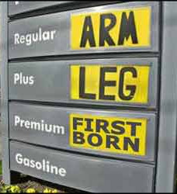

That trend continued well into 2014, before trailing off substantially in the fall of that year as the influence of the world-wide energy boom finally propagated into the US economy as a whole. These trends are nicely summarized by [AAA’s historic fuel report chart](http://newsroom.aaa.com/tag/fuel-gauge-report/) reproduced here

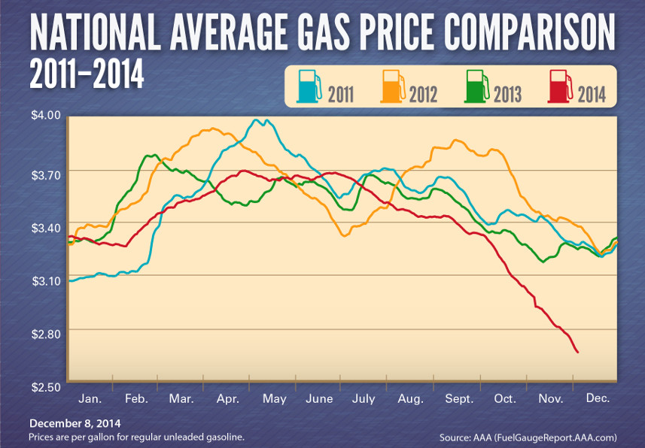

Of course the energy boom has to be understood as really resulting from two different forces. The first is the well-publicized increase in oil production around the world (supply) and the second is the profound change in driving and car-purchasing habits that many people engaged in during the oil price-peaks in 2011-2013 (demand). It is difficult to judge the interplay between these two effects to the point where a sharp line can be drawn which delineates the influence of one from the other. Nonetheless, it is clear that increase of supply of oil on the world stage is the main force driving prices.

During the ‘high price’ years, the accusation was often leveled against the oil companies that they were price gouging – their greed led to our misery. That claim may or may not be true, but it is well-supported that their ‘greed’ is the primary motivation for the current downward pressure on gasoline prices, giving us one of the longest ‘low price’ periods in recent memory.

It is conceivable that for most people this claim is nonsense. After all, if they believe greed results in price gouging, how then can greed drive prices down? The answer to this question is found in the law of supply and demand and in the outcomes of the dynamics of the [Prisoner’s Dilemma](http://commoncents.blogwyrm.com/?p=53).

The fastest way to drive up oil prices is to lower the supply relative to the demand. The law of supply and demand is a well-known principle but one whose full implications are often difficult to understand. One such point is that rising prices to do not imply rising profits. Other factors, such as market share and rising production costs, are reflected in the costs as well. In the particular case of gasoline prices, market share is the key feature.

Currently, there is more oil on the world stage than at any other point in recent times. So the ‘logical’ question to ask is why don’t the greedy oil producers simply cut production thereby lowering the supply. Lower supply with current demand equals higher prices equals higher profits.

This logic is flawed since it implies that all the oil producers are in perfect collusion with each other and that their collusion is so solid that each member will be content with the profit-sharing plan they all agreed to (predicated, of course, that they have actually entered into an agreement at all). Since the going in position is that the producers are greedy – here defined to mean that they will attempt to maximize their profits – one has to grant the strong possibility that one or more of them will betray the others when the order to lower production comes. Betrayal will mean that oil production will remain high and prices low, so that the net effect to the consumer is negligible; but to the producer who betrays first, their profits will soar as their market share increases. Since total profit is determined by profit per unit ***and*** the number of unit sold, the betrayer can increase his profit without lowering production, providing the other producers don’t think the same way.

But the other oil producers aren’t saps and they can work this out just as well as their fellow co-conspirators. So they all ‘betray’ the cartel and either keep their production steady or increase it, regardless of whatever they may say to each other. The overall effect is that greed keeps oil supplies high and prices low. This outcome is a direct consequence of free market forces and is good for the consumer.

So the next time you go to the pump and fill up your tank on $1.95/gallon gasoline, take a moment to thank a greedy oil producer for their greed.

# Brick and Mortar Here to Stay

Well we just finished another haul through that end-of-year spending frenzy that passes for yule-tide spirit. This bit a crass consumerism in the name of the virgin birth often leaves a bad taste in my mouth and a reasonably large dent in my wallet. But it also gives ample opportunity to observe and even dissect American economics with particular focus on the household-to-firm side of the three-legged stool that comprised the bulk of our economic activity.

Now before I report on my observations, I think, in the interest of full disclosure, that I make it abundantly clear, that I prefer to make the majority of my holiday purchases online. There are several reasons for this. The most important reason is that I would rather spend my precious time with family and friends rather than slogging through a mall but I would be remiss if I didn’t mention that I simply don’t like interacting with people that much. It helps that the majority of gifts I look to purchase are easily obtained with a little cyber-spending.

All that said, this past holiday season emphasized one point with emphasis. Despite dire predictions to the contrary, I see no end in sight for brick and mortar establishments.

Often over the past 10 or 15 years we’ve all heard that brick and mortar establishments – ranging from big box stores like Best Buy to mom-and-pop stores just across the street – were facing insurmountable competition from the online presences. The end was nigh so said the gloomiest of the economic pundits and yet here we are years later and brick and mortar shops are still here.

To be sure, they are not quite in the same embodiment that they were in before the internet revolution. The fierce competition from online vendors, particularly Amazon, has substantially changed the face of how books are purchased. But brick and mortar establishments have adapted in the face of this competition. They’ve capitalized on those facets of their business that give them the greatest advantage and have responded to free-market forces in a way that would make Adam Smith proud.

And what are those facets that give them an edge over the internet providers? Well, a little bit of thought should convince you that the primary advantage that brick and mortar provides its customers is what I like to call *purchase certainty*. Purchase certainty takes several forms that are best illustrated with examples.

First type of purchase certainty is certainty in the quality of the product. Most of us, I am sure, have had the experience where the item online looks good but when it arrives it is a disappointment. The one that personally affects me is the purchase of comics. I like to selectively collect comics and my emphasis is on finding good stories. I am willing to compromise on the art provided that the story has good exposition and is thought-provoking. Individual comics can run between 2 and 4 dollars for 32 pages of material at a comics specialty shop and, when it is realized that a good story can run between 10 and 40 issues, the dollar cost can be quite high in comparison with other mediums. This cost can be substantially reduced by buying in advance through online services (e.g. [Discount Comics Buyer Service](https://www.dcbservice.com/)), which gives discounts of, on average, 40%. Of course, the publishers are willing to provide this discount to receive the improved certainty in forecasting the number of books they will need to print. The flip side is that as a consumer I pay for their improved certainty with loss of certainty of my own as to the quality of the product. The brick and mortar establishment allows me to directly observe the product before purchasing at the cost of a higher price that is the premium associated with the freedom they provide and the corresponding uncertainty they face (will I or won’t I buy). Of course, brick and mortar stores are most vulnerable in this advantage since a consumer may go to the showroom to see the quality and then turn to online to buy. But I believe people are starting to become economically savvy to the fact that they can’t have their cake and eat it too and are willing to not exploit this vulnerability.

The second type of purchase certainty involves returns. As a consumer buying from a brick and mortar you know that you will have a much easier (and more certain) experience trying to make a return. Recently, my wife purchased a costume from the Amazon marketplace. When the package arrived, the item sent looked nothing like the item shown online (another example of the item quality certainty discussed above) and she resolve to return it. However, the process to return it was slow and cumbersome. It took weeks to get the vendor to even agree that they had made a mistake and another month or so to get the shipping label and receive the refund. The closure process for brick and mortar stores is faster and more certain again offering a tangible advantage over the online experience.

The third type of purchase certainty is the certainty in enjoyment. Being able to go to a brick and mortar store and find what you wanted (even if you didn’t know you wanted it until you saw it) means that there is greater certainty in getting instant gratification than is possible online. The extra time that one gets to enjoy the purchase is valuable in its own right and is yet another advantage that brick and mortar businesses offer over their online competitors.

So while it is true that some businesses have suffered from their competition with online rivals, the majority of brick and mortar stores have adapted to showcase their unique advantages. The ultimate winner is the consumer and the ultimate loser is those pundits who predicted the demise of the brick and mortar experience. Brick and mortar businesses are there to stay.

# A Growing Consensus

What do National Review, The Hill, The Orange County Register, The Week, The New York Post, The American Spectator, NPR, Vox, The Huffington Post, The New York Times, and The Washington Times all have in common. At first blush the answer is probably nothing substantial other than that they are all media outlets of one fashion or another that publish in English (spoken or written) in the United States and that each tends to cover political content of the day. But there the commonality seems to end.

National Review, The New York Post, The American Spectator, and The Washington Times are all to the right-of-center while the Hill, NPR, Vox, The Huffington Post, and the New York Times are left-of-center and The Orange County Register and The Week sit somewhere in-between.

But the fall of 2015 saw each of these publications issue articles on the structural problems and the corresponding growing issues of the Affordable Care Act (ACA). In other words, concerns about the economic integrity of the system, more commonly known as ObamaCare, are being raised all across the political spectrum and that, in and of itself, is worth noting. Regardless of your politics, the immutable facts of economics remain constant and, unfortunately, merciless.

Now to be clear, I personally like the overall aims of the ACA. The idea of opening access to regular health care to the largest possible segment of American society is laudable. As is the aim of lowering cost by competition and keeping coverage transportable by lessening the ties between policy and place of employment. These are admirable requirements that are firmly couched in the ethical notion that man is intrinsically worth something – that each human being has a value quite independent of his economic output.

But while we can ignore economics in defining our ethically-based goals we can’t ignore it in our plans to achieve these goals. Immutable laws of nature, both inanimate and human, must be taken into account. As well discussed in this interchange

<iframe width="420" height="315" src="https://www.youtube.com/embed/VdyKAIhLdNs" frameborder="0" allowfullscreen></iframe>

there is no logical support that allows us to go from the idea that human life is the most valuable thing to the idea that an infinite value should be place on an individual human life, since there is not a infinite amount of resources to apply.

And yet, the enactment of the ACA seems to have been done in full denial of this economic reality of life. The evidence for this is found peppered throughout the coverage that came out this past fall.

In the article [*Obamacare Is Dead*](http://www.nationalreview.com/article/426550/obamacare-failures), Kevin D. Williamson of the National Review, notes that of the 21 million participants need to provide a cost-sharing base, only about half are actually participating. In addition, the current demographics are heavily weighted towards the sick and/or elderly, who are looking for a payout, while the younger and healthier buyers, needed to offset the rising costs, are staying away. There are several mechanisms used by this latter group to ‘opt-out’. Some decide that their most rationale course of action is to simply pay the penalty rather than join. Others, 12 million in last sign-up cycle, took advantage of the 30 exemptions. As a result, and despite the federal subsidies, already half of the co-ops have gone under financially. Williamson also points out that the ACA further distorts the [notion of insurance](http://commoncents.blogwyrm.com/?p=38), turning it into a badly-constructed cost-sharing program, and that private industry (e.g [Medi-Share](https://mychristiancare.org/medi-share/)) does a much better job of delivering health care than government.

Robert Pear of The New York Times points out in his article [*Many Say High Deductibles Make Their Health Law Insurance All but Useless*](http://www.nytimes.com/2015/11/15/us/politics/many-say-high-deductibles-make-their-health-law-insurance-all-but-useless.html?_r=0) that many consumers are complaining that ‘sky-high’ deductibles make it impossible to actually go to see a doctor. The ACA did deliver on lower premiums true enough, but the cost was shifted into rather larger deductibles. Pear cites a median deductible of $5000 in Miami.

Deductibles this high cause a perverse outcome in which the healthiest people stay out of the exchanges altogether. The reason is that the law gives them a disincentive. David Catron, of The American Spectator, points out in his piece entitled [*ObamaCare Endures the Death of a Thousand Facts*](http://spectator.org/articles/64741/obamacare-endures-death-thousand-facts), that a consumer faced with high deductibles (some places have huge deductibles, e.g. the median in Miami is $5000 in Miami) may elect to give up their health coverage, even if the premiums are low, and pay the small penalty ($695) – it is cheaper to stay away. This approach is especially attractive since the consumer can’t be denied coverage later if a catastrophic illness were to arise.

It is true that not all plans have high deductibles. Policies with relatively low deductibles use higher premiums to offset the cost. So the consumer has to pay one way or another – either up front with the premiums or on the return with deductibles. And, as Sarah Kliff of Vox notes ([*Why Obamacare premiums are spiking in 2016*](http://www.vox.com/2015/12/14/9910650/obamacare-premiums-2016)), it looks like premiums are heading up across the board. So even affordable premiums, independent of deductible size, may be a thing of the past. In her analysis, Kliff lays the blame at the feet of insurance companies who “underestimated how sick health law enrollees would be.”

But this shouldn’t have unexpected. The ACA attracts the sick while giving the healthy (and there money) a reason to run and hide. These kinds of perverse economic incentives are at the root of massive losses in the state-run co-ops. Akash Chougule ([Obamacare Enters a Downward Spiral as Co-ops Fail and Enrollment Slows](http://www.nationalreview.com/article/425953/obamacare-health-insurance-co-ops-failing?target=topic&tid=1330)) notes that:

* 22 of 23 co-ops lost money in 2014 despite receiving $2.4 billion in taxpayer support
* Iowa and Nebraska co-op offered artificially low rates causing a tenfold increase in enrollment over what was expected; this forced the co-op into liquidation
* Louisiana’s co-op went under due to “onerous burdens” sending 16,000 enrollees looking for new policies

Chougule also points out that individual-market insurance costs rose by 49% in 2014.

I could go on but I’ll stop here by noting that I barely scratched the surface of all the articles that are out there. Additional food-for-thought is easy to find. Here is a sample

* [*ObamaCare's predictable collapse*](http://thehill.com/blogs/pundits-blog/healthcare/260948-obamacares-predictable-collapse) – Rick Manning of the Hill
* [*Obamacare at 5: Sick and getting worse*](http://www.ocregister.com/articles/obamacare-691964-government-insurance.html) – Mark Landsbaum of The Orange County Register
* [*The quiet unraveling of ObamaCare*](http://theweek.com/articles/589920/quiet-unraveling-obamacare) – Shikha Dalmia of The Week
* [*A new taxpayer bailout to cover up ObamaCare’s failure?*](http://nypost.com/2015/11/20/a-new-taxpayer-bailout-to-cover-up-obamacares-failure/) – Betsy McCaughey of the New York Post
* [*Many Health Co-Ops Fold, Others Survive Startup Struggles*](http://www.wfdd.org/story/many-health-co-ops-fold-others-survive-startup-struggles) – NPR
* [*The Figment of Affordable Health Care*](http://www.washingtontimes.com/news/2015/dec/14/editorial-the-figment-of-affordable-health-care/)  - Washington Times

Each and every one, spanning all parts of the political spectrum, is touting the gloom and doom of the ACA. Each and every article serves as a reminder that there is no such thing as a free lunch.

# No Chinese Free Lunch Today

It was only about 4 scant months ago that [I wrote a column about China](http://commoncents.blogwyrm.com/?p=232) and the real and present dangers it presented to the global economy. And here we are on the edge of the meltdown, watching as the Chinese stock market drops and drops in value.

Nothing seems to help during this latest flurry of devaluation on the Chinese Stock Market. The automatic circuit breakers halted trading on two separate occasions before the Chinese government concluded that they were doing more harm than good. The market then proceeded to tank again. And despite all this turmoil, the central government keeps beating the drum that growth in the economy is still on pace for 6-7%.

Meanwhile, back in the United States, many market participants on the NYSE or NASDAQ have lost their collective heads and have begun selling everything off in sight. Of course, cooler, less-emotional heads are buying and at a discount but it looks like the public at large doesn’t care. There is an old saying, which goes something like “the beatings will continue until morale improve”, that applies here.

I bring up these crazy, irrational responses as way of a prelude to the main point here. Human behavior gets muddled when strong emotions are roiling under the surface. Nothing new there! And few things engender strong emotions as much as money – or more precisely the freedom that having lots of money implies. But the less-cynical-me had hoped that paid professionals in both the financial and media sectors to be able to detach emotion and discuss objectively.

Anyone with common sense and the ability to keep their emotions in check would have been able to warn that the ‘China miracle’ was anything but. There was no shortage of voices who were questioning the Dragon’s wisdom in constructing high-rise apartment buildings in which no one lives, or the raising of large malls where no one shops. And yet, China’s ‘new economy’ made headlines all over the world.

Even now, with the precipitous loses of the last two weeks, the best that seems to come out of ‘money reporting’ are tame and vapid pieces like Heather Long’s [*Why China doesn’t know what it’s doing*](http://money.cnn.com/2016/01/15/investing/china-stock-market/index.html?iid=hp-stack-dom). Ms Long’s lead in reads

<China's growth miracle is cracking. The country no longer seems to know what it's doing when it comes to the economy and, especially, financial markets.>

Huh? When did China ever know what it was doing? I’m willing to bet that she is someone who would dismissively scoff at the ordinary sorts of miracles that those religious ‘country bumpkins’ accept.

Later in the piece she is willing to ask the question

But here's the real takeaway: Why did it take the rest of the world so long to figure out that China didn't have it all under control?

I would love to see what she would have said if she were reporting on the pyramid scheme of Bernie Madoff. Perhaps her text would read

<Madoff’s investment return miracle is beginning to crack. He no longer seems to know what he is doing with his client’s money. But the real takeaway is why none of us ever questioned how his get-rich-quick, never-downturning-growth could be sustained. Silly us, maybe we should give his genius a second chance.>

And so the more-cynical-me jumps to a conclusion that it wishes to share. There will always be buffoons in the market, like rubes in at the circus. Eager to see something new or strike it rich or whatever, they are willing to suspend not only disbelief but common sense. They are quite willing to look the other way while their pocket is picked clean. Some members of the financial industry and of the intelligentsia in the media aid in this shearing by acting as either side-show barkers or as those encouraging bystanders who tell us “What have ya got to lose.” Other members act as the ‘friends’ who consoles us with platitudes about it not being our fault or how could we have known or it was just bad luck. Only a few, honest ones continue to tells us that there is no such thing as a free lunch. I just don’t think many of us will ever listen those guys.

# How Neutral is Net Neutrality?

*Unintended consequences*. That phrase could be the rallying cry for millions of people adversely affected by either poorly conceived or too-broadly applied regulations. Often these regulations, which are usually put in place to protect the economic interests of one party against the encroachments or abuses of a second party, have harmful side-effects on a third party – what economists call negative externality. Net neutrality seems to be one such type of regulation rife with all sorts of unintended consequences.

The aim of net neutrality seems noble. Keep the internet free from interference by the internet service providers (ISP) so that there is an uninterrupted conduit from content-provider to content-consumer, regardless of the nature of the content or the identities of provider or consumer. The ISP should act as a public utility maintaining the infrastructure through some equitable fee structure so that big and small alike can achieve the same throughput but, otherwise, should stay out the way.

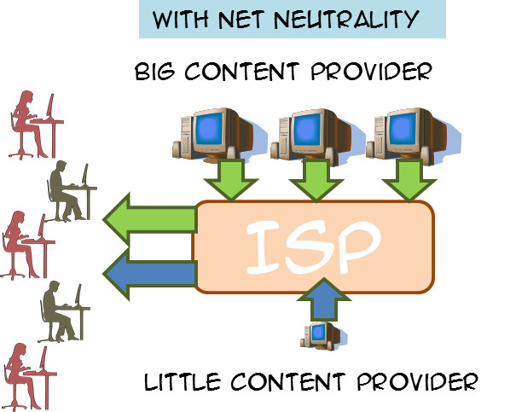

The concern that is being addressed can be best illustrated using a hypothetical situation. Suppose that two content-providers are competing for the hearts and minds of the great movie-streaming audience out there. One is a large well-established firm, like Netflix, and the other a smaller, newer company, like Hulu, that can be view as upstart competition. The situation that net neutrality is supposed to prevent is where an ISP, such as Comcast, enters into an agreement with the larger provider. The nature of the agreement is that the ISP will enhance the bandwidth of the larger streaming service, throttle the flow from the smaller competitor, or both in return for additional compensation.

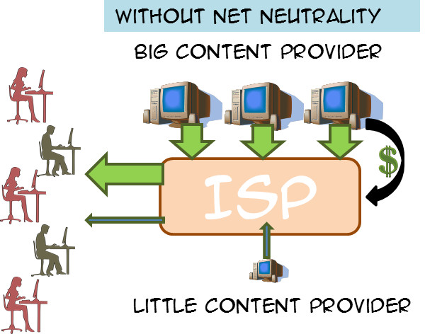

Supporters of net neutrality point to the fact that the net result of such an agreement is that the smaller provider faces an extremely large barrier to entry. They need to have capital to cover not only their operating costs but also to ‘grease the palms’ of the ISP. Small business thus starts out on a playing field that is far from being level. Furthermore, consumers are harmed when denied access to all content and that they end up paying more for two reasons. First, the larger content provider has less competition thus ensuring that it has a consistently high demand almost independently of the price it sets. Second it wants to pass on the cost it incurred in making the deal with the ISP onto its customers and can do so without fear.

Detractors point to the fact that government intervention in the free market often does more harm than good, that the government regulation stifles free speech and harms entrepreneurship. An additional critique that occurs to me (but which I haven’t seen expressed in the debate) is that compliance with government regulations is often so expensive that it constitutes a barrier to entry for small businesses. So net neutrality may enhance completion between service providers big and small but it may substantially diminish competition in the ISP market.

Obviously, the net neutrality argument is heavy and heated and extremely complex, with government being asked to balance a multitude of competing wants and needs. I’m not sure what is the best solution and I am not going to remotely try to explore all of the pros and cons. Rather I wish to comment on a small and interesting l little corner that has recently come to my attention.

In her piece [*Net Neutrality and Religion*](http://capx.co/net-neutralitys-religious-freedom-problem/), Arielle Roth points out that an unintended consequence of the net neutrality is the chilling effect it would have on smaller ISPs who tailor their offering to a particular customer base that wants certain corners of the internet off limits. The usual scenario is one where a religious demographic would like to restrict access to pornography, or sacrilegious or blasphemous content. These customers want to enter into a legal contract with the ISP in which they pay to the ISP to deal with the segments of free expression for them. In other words, these customers want someone to shield them from content they would find offensive and they are willing to pay for the service.

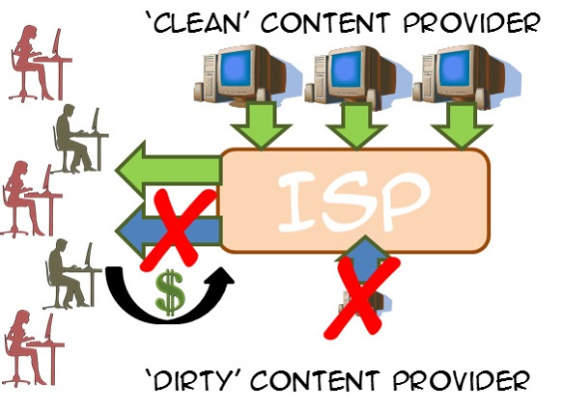

Such a service would be in violation of net neutrality since it would disadvantage a ‘dirty’ provider (say Playboy) relative to a ‘clean’ provider (say Billy Graham) even though the customer wants that disadvantage. And it isn’t clear at all how to write an exemption that respects one scenario without running afoul of another scenario. How should the government define ‘excludable content’ from ‘essential content’ without encounter the slippery slope type of arguments that manage to make all content excludable or essential.

Some free speech advocates will, no doubt, say that this is the price we pay for free speech. But that argument is not persuasive. Free speech protections guarantee an individual’s right to say just about anything (within some narrow limits) but it doesn’t guarantee that anyone must listen. And besides, there is an equally valid constitutional argument that says individuals have the right to freedom of association, which means they have the right to not associate with content they deem unacceptable.

And so this little corner of the net neutrality debate shows just how complicated and thorny it can be to try to regulate economic behaviors.

# Bad Logic on Trade & Inequality

I came across two articles recently that caught not just my attention but also my ire. They were excellent examples of what is wrong with much of the policy material that comes out of the ‘dismal science’.

Simply put, the presentation of evidence and the offered arguments built on this evidence is too scant to be respectable. The conclusions reached are too certain with no countervailing opinions considered or addressed, except in passing. The tones of the articles were too much schoolyard ‘see I told ya so’ and too little of the scholastic ‘let’s weigh all sides and pick the best path, regardless of who is right.’ Their logic is faulty and their argumentation depends on tautologies and equivocation rather than well-formed formulas required. In short, they are polemical opinion pieces better suited for a candidate running for office than they are serious pursuits of truth. And the validity of their conclusions is, shall we say, dismal.

In the first example is a recent article about economic inequality by Christine Lagarde, entitled [*Equality is key to global economic growth*](http://www.bostonglobe.com/opinion/2016/01/27/equality-key-global-economic-growth/Kr1v7J5xl0hiHZpD4PZkIK/story.html). Lagarde is currently the managing director of the International Monetary Fund (IMF). A lawyer by training, she has held a variety of economics-related roles, including as an antitrust and labor lawyer and as France’s Trade Minister and Minister of Economic Affairs. So I had hopes that her article would offer a well-thought-out support of the position so concisely summarize in her title.

Instead, I found a fluff piece with numerous examples of equivocation. For instance, the third paragraph of the article reads:

<We at the International Monetary Fund are supporting our 188 member nations in that effort. We do this through our core activities — lending, policy advice, and technical assistance — as well as by helping to deal with a set of emerging issues that are of increasing importance to them: female empowerment, energy and climate change, and reducing excessive inequality.>

Surely a definition of ‘excessive inequality’ would be coming after such a lead-in. Does she mean wealth inequality, income inequality, or some other form of inequality? After all, the inequality between Warren Buffet and the average wage earner in the US is much smaller when considering their incomes versus net wealth. Buffet makes a comparatively small income (defined as wages and salaries) every year but resides over a vast fortune.

But alas no. Lagarde does say about inequality that:

<The traditional argument has been that income inequality is a necessary by-product of growth, that redistributive policies to mitigate excessive inequality hinder growth, or that inequality will solve itself if you sustain growth at any cost.>

What kind of logic is being used in this sentence? It is almost certain that wealth inequality is a necessary by-product of economic activity. But where did income inequality creep in. And what is excessive inequality. At what value of the [Gini Coefficient](http://commoncents.blogwyrm.com/?p=83) does income inequality become excessive? And so what if there is income inequality, it doesn’t mean anyone is poor. Both the players and owners in the National Football League are quite well-off, even though there is a distinct income inequality between the scant millions earned by the players versus the meatier hundreds of millions and billions earned by the owners.

Without any additional support, Lagarde then goes on to say that:

<[The IMF has] found that countries that have managed to reduce excessive inequality have enjoyed both faster and more sustainable growth. In addition, our research shows that when redistributive policies have been well designed and implemented, there has been little adverse effect on growth.>

How much faster and how much more sustainable is the growth – would 0.1 % be statistically significant? How little is little adverse effect on growth – would 20% be little? Sigh…

Lagarde ends with this chestnut

<What is crystal clear, however, is that excessive inequality is a burning issue in most parts of the world, and that too many poor and middle-class households increasingly feel that the current odds are stacked against them.>

There is no rationale statement in that sentence other than to say the ‘excessive inequality’ (still undefined) makes people say that they feel bad.

So much for Lagarde!

The next candidate in the bad logic hit parade is the article entitled [*Free Trade With China Wasn’t Such a Great Idea for the U.S.*](http://www.bloombergview.com/articles/2016-01-26/free-trade-with-china-wasn-t-such-a-great-idea) by Noah Smith. Smith’s bona fides tell us that he is an assistant professor of finance at Stony Brook University. So I had hoped for a well-reasoned discussion. But those hopes were soon dashed.

Smith is more subtle with his equivocation and, as a result, his misdirection is harder to spot. His starting position is that:

<[E]conomists often portray a public consensus while disagreeing strongly in private. In effect, economists behave like scientists behind closed doors, but as preachers when dealing with the public.

Nowhere is this evangelism clearer than on the issue of trade. Ask any economist what issue they agree on, and the first answer you’re likely to hear is “free trade is good.” The general public disagrees vehemently, but economists are almost unanimous on this point.>

These two paragraphs, examined closely, open all sorts of questions about Smith’s positions. First, by his own rules, should we be regarding Smith as a preacher rather than a scientist, since he is talking in public? Second, is being a preacher bad or, perhaps, is Smith revealing both his ignorance and his bias when it comes to [faith and science](http://aristotle2digital.blogwyrm.com/?p=430)? Anyway, let’s leave these questions aside and focus on the question he would like us to focus on. Is free trade with China bad?

To support the premise of his title, Smith provides us with this little gem:

<[L]ook at actual economics research, and you will find a very different picture [on free trade]. The most recent example is a paper by celebrated labor economists David Autor, David Dorn and Gordon Hanson, titled “The China Shock: Learning from Labor Market Adjustment to Large Changes in Trade.” The study shows that increased trade with China caused severe and permanent harm to many American workers.>

Increase trade equals free trade? Smith argues that Autor, Dorn, and Hanson’s findings support that:

<Autor, et al. show powerful evidence that industries and regions that have been more exposed to Chinese import competition since 2000 -- the year China joined the World Trade Organization -- have been hit hard and have not recovered.>

My response is – so what? I feel for these people who have been hit hard and have not recovered. Collectively, we as a nation should do something, and individually, me as a person should do (and am actually doing) something. But where is the evidence that free trade is the culprit?

How do I know that some economists or lawyers or professors of finance haven’t rigged the trading with China to favor themselves? After all, income inequality (or is it wealth inequality) has to come from somewhere. Or maybe government policy has left trade unfettered but has prevented these displaced persons from finding other jobs. Perhaps welfare and unemployment benefits are perversely constructed so that the displaced worker has no incentives or options to support himself while he looks or trains for new jobs. Perhaps, in an imperfect world, the benefits to society as a whole far outweigh the localized losses, as painful as they may be.

There are lots of questions and no forthcoming answers because Smith avoids examining these questions entirely. He seems to simply want to inflame the passions of a populist subject. Just the kind of behavior I would expect to see from a fly-by-night preacher.

So let me close by saying that one should stay on one’s toes when reading articles that pass for economics but are really politics. When the author argues without defining terms, without presenting quantitative evidence, and with liberal shortcuts through logic they probably aren’t worth one’s time.

# Tinkering with Equilibrium

The genesis of this column is mostly based on chance; a chance visit, a chance purchase, and a chance reading. Nonetheless, the end result is a nice example of how government interventions in a market can look good on the surface but have a less-attractive side underneath.

Let’s start with the chance visit. Recently, I had an occasion to stop off at a used bookstore near a college campus. The basic function of this establishment is to buy back textbooks at a cheap price, resell the products back to others at the going rate for used textbooks, and to store the unwanted product as tastes and approaches in teaching and the professors who are teach change. The fact that the resell price is significantly higher than the buy-back price seems to irritate the bulk of the clientele (judged by my casual viewing of the interactions at the register). The reason for this cost-differential – that this particular book store needs to pay for the storage of the books, the labor of the various people who catalog and handle the product, as well the rent and upkeep of the shop – slips by the average consumer. And, although this column is not explicitly about this mismatch of expectations, the basic theme of the unseen cost is. Looking back in hind sight, these preliminary observations of mine were perhaps a foretaste of what fate had in store.

In any event, I began to wander about the store; an adventure in and of itself considering the vast number of abandoned titles piled precariously all over the floor. Training in the high hurdles would definitely be an advantage when browsing the inventory. Turning a corner, I came across the store’s collection of Schaum’s outlines. Overall, I am a fan of these do-it-yourself study guides. Not so much due to their teaching style, which is often minimalistic and confusing, but rather the vast number of worked problems that one can immediately dig into. The effect they produce is a lot like finding a bunch of how-to videos on YouTube with the convenience of the at-your-own pacing that book afford. Glancing at the shelf, my eye caught the title *Microeconomic Theory, 3rd Edition*, by Dominick Salvatore of Fordham University and, almost on a whim, I decided to purchase it for a mere $5 dollars (which goes to show that you can get a bargain if one is willing to settle for yesterday’s textbooks and study guides).

In odd moments, here and there, I began to dip into the outline and amuse myself with some of the questions and solved answers. Early on in the book, Salvatore goes to some effort to set the scope of the study to be strictly microeconomics. Interconnections of one market to the next are to be kept to a minimum. So I can’t blame him for what I found shortly thereafter but I thought it made for a good ‘teachable moment’ about ignored or unseen costs.

The scenario he explores is clearly contrived for pedagogical purposes, but I reason that if it is sufficiently illustrative to go into a Schaum’s outline, it is also sufficiently realistic to serve as a valuable thought experiment. In this scenario, the micro-portion of the economy that is being examined consists of 10,000 consumers and 1,000 producers of a particular product, which he calls ‘X’. For simplicity, each of the consumers possess the same demand curve given by

where is the quantity demanded of for a given price that they must pay. Likewise, each of the producers follows a supply curve given by

where is the quantity they are willing to supply if they can charge price . The prices that the consumer pays and that the producer demands equal each other when the market is in equilibrium. The following figure shows the demand and supply curves for this market.

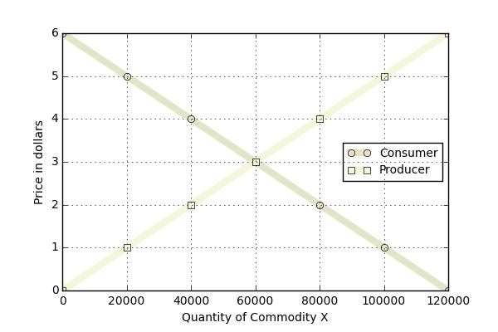

From the figure, the equilibrium point, where the two curves cross, falls at $3 and 60,000 units produced. We can confirm this result by solving the equation

where and .

Salvatore then directs the reader to consider the case where the government decides to intervene in this market by providing a subsidy to the producer of $1 per unit produced. He asks:

<(a) What effect does this have on the equilibrium price and the quantity of commodity X? (b) Do consumers of commodity X reap any benefit from this?>

Part (a) is a bit tricky to solve in that one must first decide what is exactly meant by a $1-dollar subsidy. In short, it means that the producer now perceives that he can charge a dollar higher than he could without the government intervention. Ignoring for the moment that the new equilibrium will move, the producer gets $4 when a consumer pays him $3 since the government is stepping in with an additional $1. As a result, the producer’s new supply curve is

Functionally, this looks as if the producer’s supply curve has been shifted down by $1 as seen in the figure below (the new, shifted curve is labeled ‘Government’).

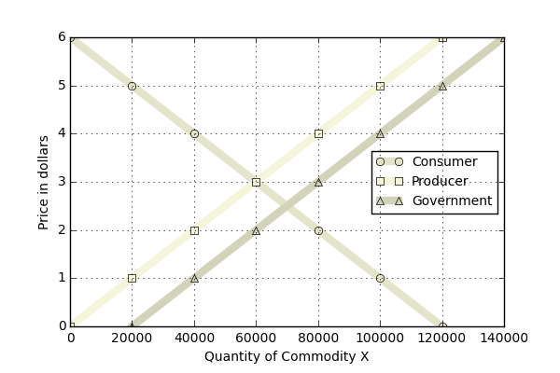

The new equilibrium is solved as before, and either direct inspection of the graph or algebraically solving

results in the new equilibrium of 70,000 units produced at $2.50 per unit. Salvatore then points the student to the conclusion that this government intervention has benefitted the consumer since price has fallen by 50 cents per unit. By analogy, this analysis also suggests that the producer is better off in that more units have been produced.

And this is where I got perturbed by the strict adherence to microeconomics. It is true that this market seems to have been helped but there are unseen costs that at a minimum could have be discussed even if the implications to other markets were avoided.

Specifically, before the government intervention, a total of $180,000 dollars moved from consumer to producer in this market (60,000 units at $3/unit). After the government intervention, a total of $245,000 dollars moved to the producers in this market. It is true that the 10,000 consumers only shouldered $175,000 of that cost but it is wrong to ignore that the producers actually received $70,000 in government subsidies.

Where did that additional $70k come from? It is easy and tempting to say that it comes from the government and to stop there, but that misses the point. Where did the government actually get that money? Well it could have printed it or it taxed it. If it printed it, the cost of that action eventually comes back in the form of inflation, which devalues the consumers buying power, resulting in a new set of supply and demand curves. More likely, it taxed it, which means it took money from consumers, some who weren’t that market, and injected it into this market. It made some consumers reap a benefit at the expense of others suffering a loss.

Of course, this scenario is contrived but the logic and the lesson is not. The point here is that it is easy to see the direct costs and to ignore the hidden or indirect costs. As long as a citizen doesn’t dig too deeply, he probably never knows when he is being robbed blind.

# More than an Ultimatum

A while back I wrote on the [Ultimatum Game](http://commoncents.blogwyrm.com/?p=120), an experiment in the psychology of behavior in the marketplace which showed that people rarely act purely in their material self-interest. More often, they balance the possibility of material gain against the other, less tangible or intangible factors, such as self-esteem and pride.

The premise of the game is that two people are put into the situation where they stand to both benefit materially by splitting a sum of money between them. The catch is that the details of the split can’t be negotiated. One person is granted the authority to propose a split (e.g. 50-50, 90-10, etc.) and the other is granted the authority to either accept or reject the proposal. Acceptance nets both parties the agreed-upon sums. Rejection makes both parties walk away empty-handed. Classical economic theory predicts that the deal is accepted in all cases where the second party stands to receive something in the way of a split – that is to say when the split is anything other than 100-0. Real experiments with real people suggest that splits far from equitable (i.e. 50-50) have little chance of succeeding despite the fact that the second person stands to walk away with a material gain.

One of the criticisms leveled against the outcome and analysis of the Ultimatum Game is that the stakes may be too low to really make a difference. After all, the argument goes, most of the real world experiments are done with sums like $100, which is, relatively-speaking, chump-change. Economists and psychologists have attempted address this critique by normalizing the results by offering the same sums in different economic scenarios, like the third world, where $100 has significantly more buying power than in the US. Nonetheless, the critique that the game hasn’t really been played for high stakes is a valid concern. Perhaps there is a mind-bogglingly large sum for which even a 90-10 split will be always accepted.

Well Shankar Vedantam, of NPR, ties the Ultimatum Game to one of the biggest stakes out there – the negotiations on climate change. The report, entitled [The Psychological Dimension Behind Climate Negotiations](http://www.wfdd.org/story/psychological-dimension-behind-climate-negotiations), aired on NPR the week of Nov. 24, 2015. In it, Vedantam argues that the same psychology seen in the Ultimatum Game explains why countries with the most to lose by adverse climate change may actually walk away from a deal that benefits them.

To back up this claim, Vedantam called upon the expert testimony of David Victor, a professor in the School of Global Policy and Strategy at UC San Diego and the director of the UCSD Laboratory on International Law and Regulation. Victor, who has published extensively on the politics of climate change, had this to say about the interplay of gain and fairness

<Look at the last big conference on climate change in Copenhagen in 2009, where a deal was on the table. The least developed countries refused to accept that deal because they thought the deal was unfair, and they felt they had been left out of the room when the deal was negotiated. And so they were willing to walk away from something that would've been better than nothing, precisely because they thought it was unfair. – David Victor>

In other words, despite the fact that each of these negotiators represents millions of people and are, ostensibly, rational professionals, they are still human beings who value fairness over material rationality. In fact, according to studies cited in the report, professionals may actually value fairness more, especially when negotiating with other professionals.

That may be true but I suspect that the answer is closer to a point touched upon by Vedantam himself later in his report, although he muddled-up the thinking. Said he, when asked about the fairness component of the climate-change negotiations

<I think this goes back to the ultimatum game we just talked about, Steve, which is that countries don't always do what's in their rational self-interest if they feel the outcome is unfair. I think many poor countries feel that rich countries - such as the United States and countries in Europe - have had a century or more to industrialize and build up their economies. And as a result of doing so, they have pumped these greenhouse gases into the air that have caused climate change. And these countries feel, hang on a second; you're now telling us that we have to control greenhouse gas emissions just at the point at which we are starting to industrialize. That's not fair. - Shankar Vedantam>

A careful reading of the above quote can actually lead to a different interpretation. Perhaps the ‘poor countries’ (developing countries) recognize a greater rational self-interest in continuing to industrialize than in limiting their growth in order to limit their carbon emissions. Unlike the Ultimatum Game, where the outcome is clear cut – walk away with some cash or no cash – the situation in climate negotiations is quite different. The developing countries must decide between two options, each with both a gain and a loss. So it is entirely possible that they have a rational reason for refusing a deal that benefits them in a one sphere but harms them in another.

# Robbing Peter to Pay Paul

There is a curious thing about the Eurozone that doesn’t get much notice but it really should. On the surface, the Eurozone seems to be a similar economic model to the United States, but the lack of a common culture and free movement within the member countries results in barriers that can actually cause wealth transfer from poorer members to richer ones.

In the US, an individual can move freely between the states (although setting up residency is a bit harder). Interstate purchases are open and easy, especially in the age of the internet. Workers can move from states with declining economic prospects to those with an uptrend, resulting in the kind of demographic shifts such as the recent influx into Nebraska and Texas and corresponding exodus from California and New York. In other words, things have a way of evening out since the barriers for trade between the states are very low (but not nonexistent – consider that many decisions made in California set standards across the other 49 states). Very few products made in the US are distinctly branded by the state in which they were produced. Most of us are aware that there are Florida Oranges and Idaho Potatoes but beyond that few of us know where a good is produced.

Take automobiles. Once it was obvious which cars were produced in Detroit but now few people actually know, or care, in which state is located the manufacturing plant that birthed their car. Likewise, few of us are conscious where most of the things we purchase originate.

The Eurozone, in contrast, is much more rigid. The euro is the shared currency throughout the Eurozone but the mechanics of inter-zone trade works quite differently from the US experience with the dollar. The major difference is that in the Eurozone goods, services and labor from one country are produced essentially independently from the other countries. When one is in Germany, say in the city of Munich, one is clearly aware what products are imports (mostly clothes) and what products are German in origin (most everything else). This is especially true in the realm of cars. It makes no sense to talk about Pennsylvania cars as distinguished from Montana cars but it is quite natural to talk about German cars as compared to those from France, Sweden, or Italy. In addition, French workers can’t just pick up and head for Germany any more than they could to Japan. There are barriers – political, cultural (language in particular), legal, and bureaucratic – that really impede that kind of movement.

To see how these barriers provide a mechanism for wealth transfer, start with a simple model of international trade limited to just two countries. Let country G stand for Germany and U for the United States. Both countries have their own currency (gold coin denoted as D for G and greenbacks and silver denoted as U for U) and the exchange rate between the two is shown in the yellow box. Time progresses from left to right.

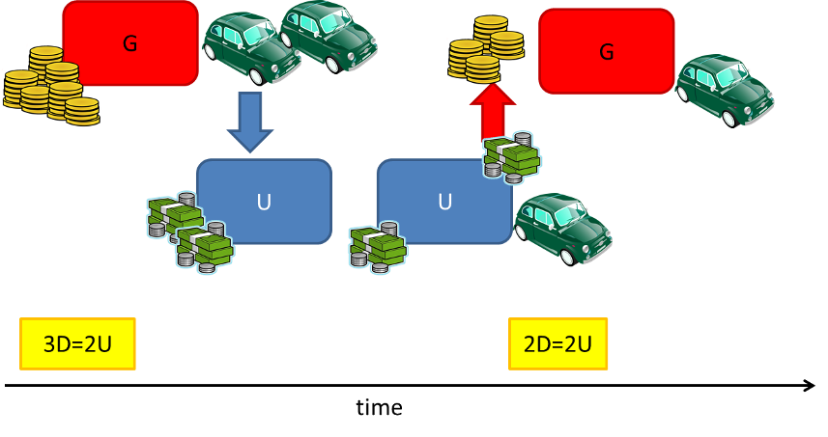

Now suppose the good that is being traded is cars; G has cars it wants to sell to people in U. At the initial time, the exchange rate favors G, as its currency is undervalued compared to U, and G promptly ships some number of cars to U. Upon arrival in U, the cars make their way to a dealership where a citizen of U, call him C, purchases one. C pays for the car with U currency and happily drives away completely unconcerned with how the money makes its way back to G; that isn’t C’s problem. G’s agents in the U have to deal with that. They do so by finding someone willing to buy Us for Ds. Since the supply of Us in the exchange market goes up, there is a downward pressure on the value of Us compared to Ds and soon the exchange rate reflects that by adjusting the buying power of G, compared with U, down to parity. This floating currency exchange serves to naturally limit the number of cars that G can sell in U and an equilibrium results.

Next, expand the model so that G is part of a larger economic entity comprised of itself and H (H stand here for Greece – either because H comes after G or because Hellenic is an adjective used for ancient Greece; the reader is free to decide for himself. Also suppose the H has no goods to trade with U at all.

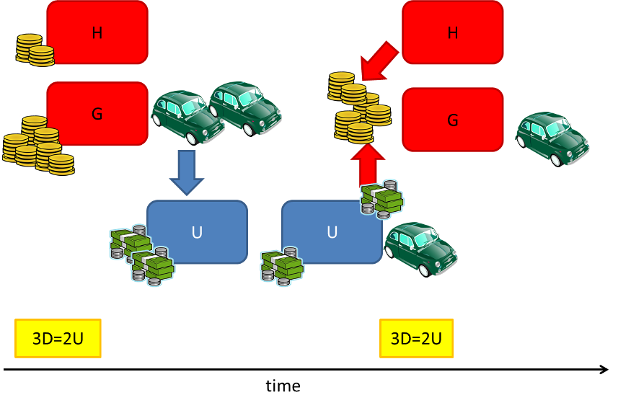

Now suppose the same situation occurs in this new model as occurred in the old. G has cars to sell and U has people wanting to purchase them. H is a complete bystander in the first leg of the transaction, having no goods to ship to U. However, H plays a pivotal role when the currency exchange occurs after the purchase. Since there is a larger supply of D, as H has a supply in addition to G, there is less of a mismatch on the exchange market and less of an upward pressure on D. Simply put there are now fewer Us chasing Ds in a relative sense. It takes longer for an equilibrium to set and during this time, H’s purchasing power is remains low.

So although there is no direct exchange of either currency or products between them, H effectively transfers wealth to G in the form of better export conditions for G and poorer import conditions for H. The poorer H is, the more pronounced is the drag it produces on the upward trend in D, the longer it takes to reach equilibrium and the more wealth is transferred. If people could move freely between H and G, then a mechanism would exist to equilibrate faster and more citizens of H would share in G’s windfall.

Although these models are highly simplified, they reasonably capture the essence of the tricky situations that result with import/exports and currency exchanges. Several interesting articles exist (a nice one can be found [here](https://history.state.gov/milestones/1969-1976/nixon-shock)) on similar situations during the Nixon presidency that ushered in the end of the Bretton Woods System. But that is a story for another day.

# Of Monks and Coffins

A recent death in the family has gotten me thinking about, amongst other things, free enterprise and economic liberty. I know that that is a strange combination but it all stems from a fairly recent legal battle between an abbey of Benedictine monks and the Louisiana Board of Embalmers and Funeral Directors. At the center of the conflict was whether or not the monks had a constitutional right to sell hand-crafted coffins as a way to raise money for the abbey. As the dispute worked its way through the courts two things became clear. First, the monks had a clear, constitutional right to engage in free enterprise and, second, that the state laws put in place to protect the funeral industry were a textbook example of how licensing and regulation often shields businesses from competition under the guise of protecting the public from harm.

The genesis (if you can forgive the biblical pun) of the showdown started just after Hurricane Katrina had devastated much of the gulf coast portion of Louisiana. The Benedictine monks of St. Joseph Abbey near Covington had [lost much of their timberland](ohttp://www.nola.com/crime/index.ssf/2012/10/federal_court_rules_in_favor_o.html) and looked for a new way to supplement their income. For years, like other monastic orders, they had fashioned coffins for the burial needs of their departed brother. In 2007, the abbey established St Joseph’s Woodworks to sell their hand-made caskets to the public.

No sooner do they get started than the Funeral Directors slap a [cease-and-desist letter](http://www.nola.com/crime/index.ssf/2013/07/louisiana_funeral_directors_wa.html) in their direction citing a state law that only allows caskets to be sold to the public by a state-licensed funeral home. The letter threatened the monks with thousands of dollars in fines and prison sentences up to 180 days for noncompliance.

The monks didn’t take that lying down and, aided pro bono by the Institute for Justice, sued in Federal court to have the law overturned on the grounds that it was an unconstitutional statute designed to protect ["cartel for the sale of caskets within Louisiana"](http://www.nola.com/crime/index.ssf/2013/07/louisiana_funeral_directors_wa.html).

U.S. District Judge Stanwood Duval agreed with the monks and ruled the law unconstitutional. He [noted in his ruling](http://www.nola.com/crime/index.ssf/2012/10/federal_court_rules_in_favor_o.html) that the coffins sold by the monks were significantly less expensive than those sold at funeral homes and that

To be sure, Louisiana does not regulate the use of a casket, container, or other enclosure for the burial remains; has no requirements for the construction or design of caskets; and does not require that caskets be sealed. Individuals may construct their own caskets for funerals in Louisiana or purchase caskets from out-of-state suppliers via the internet. Indeed, no Louisiana law even requires a person to be buried in a casket. Judge Stanwood Duval

The Louisiana Board of Embalmers and Funeral Directors took their case to the 5th Circuit Court of Appeals but to no avail. The appeals court upheld Duval’s ruling [noting in addition](http://www.nola.com/crime/index.ssf/2012/10/federal_court_rules_in_favor_o.html) that regulation is aimed at restricting intrastate competition and that

There are no other strictures over their quality or use. The district court found the state's scheme to be the last of its kind in the nation. The state board had never succeeded in any enforcement actions against a third party seller prior to its effort to halt the abbey's consumer sales. 5th Circuit Court of Appeals

The matter finally came to closure when the Supreme Court refused to hear the case, leaving the finding of the unconstitutional nature of the law in place.

For those unwilling to parse some of the legal wordsmithing in the previous two quotes a simple summary does just as well. The courts found that the state law was not concerned with protecting the public from shoddy coffins. Indeed, no coffin seems to be required in Louisiana – just dig a hole and plop the body in. But the law was concerned with protecting funeral homes from in-state competition from a bunch of monastic hooligans.

Apparently coffin business is quite a market – I suppose because no one is particularly inclined to haggle when dealing with the death of a loved one. I was curious how much caskets cost and one quick trip to internet brought me to [Best Price Caskets](http://www.bestpricecaskets.com/). Several interesting admonitions sit top and center on their website including

Do Not Tell The Funeral Home About Purchasing Our Casket Before You Get Their Itemized Funeral Price List. Call Us Before Talking to ANY Funeral Home, Because Everything You Tell the Funeral Home Affects Your Funeral Pricing. We will tell you what to say.

And

It Is Federal Law: Funeral Homes MUST receive our caskets and NOT charge you any extra fees! This cuts your funeral cost by up to 80%. We supply funeral homes and we also sell directly to you! Same Price. Buy Direct.

And this curious image

All the monks were trying to do was to engage their economic freedom and supply a demanded good in return for monetary compensation. They were filling a need at a reasonable price and that competition was feared by the entrenched businesses that lobbied for the state law that protected them.

So the final question to ask ourselves is this: what other industries, through the mechanism and licensing and regulation, are pretending to protect us while really protecting themselves. Look around, I think you’ll find more than you might, at first, expect.

Slammed by the ACA

<http://www.wsj.com/articles/lammed-by-obamacare-1457395478>